PROJECT – PASSION

END USER TRAINING DOCUMENT
FOR
TRAVEL MANAGEMENT

Prepared for



Document Managment

Prepared By
Name | Roles / Responsibility | Date
Suraj Navale | SAP HCM Consultant | 06.06.2021

Reviewed By
Name | Roles / Responsibility | Date | Signature
Babaiah Cheppali | Senior SAP HCM Consultant

Table of Contents

Overview 4
cREATE TRAVEL REQUEST (NEX) 4
aPPROVE TRAVEL rEQUEST 10
APPROVE TRAVEL ADVANCE 12
cREATE POSTING RUN 13
POSTING RUN MANAGEMENT 17
Travel expenses report 20
aPPROVE TRAVEL EXPENSES REPORT ………………………………………………………………………………………………………….26
cREATE POSTING RUN ………………………………………………………………………………………………………………………………..27
POSTING RUN MANAGEMENT …………………………………………………………………………………………………………………….30

OVERVIEW
How to process Travel Advance in SAP Travel Management?
We have configured a wage type-8077 for travel advance payment. This wage type-8077 is mapped to GL Account-21400104 using symbolic account in SAP.
Steps for travel advance process: -
TRIP –Create Travel request
PR05-Approve Travel Request
PR03-Approve Travel Advance
PRFI-Create Posting Run
PRRW-Posting Run Management

Create Travel Request
Enter TCODE-TRIP in the command bar
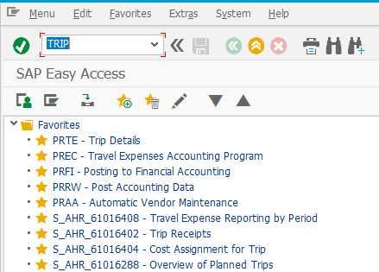
Press ‘Enter’ from the keyboard
Manually specify employee’s personnel number as shown in the below snapshot.
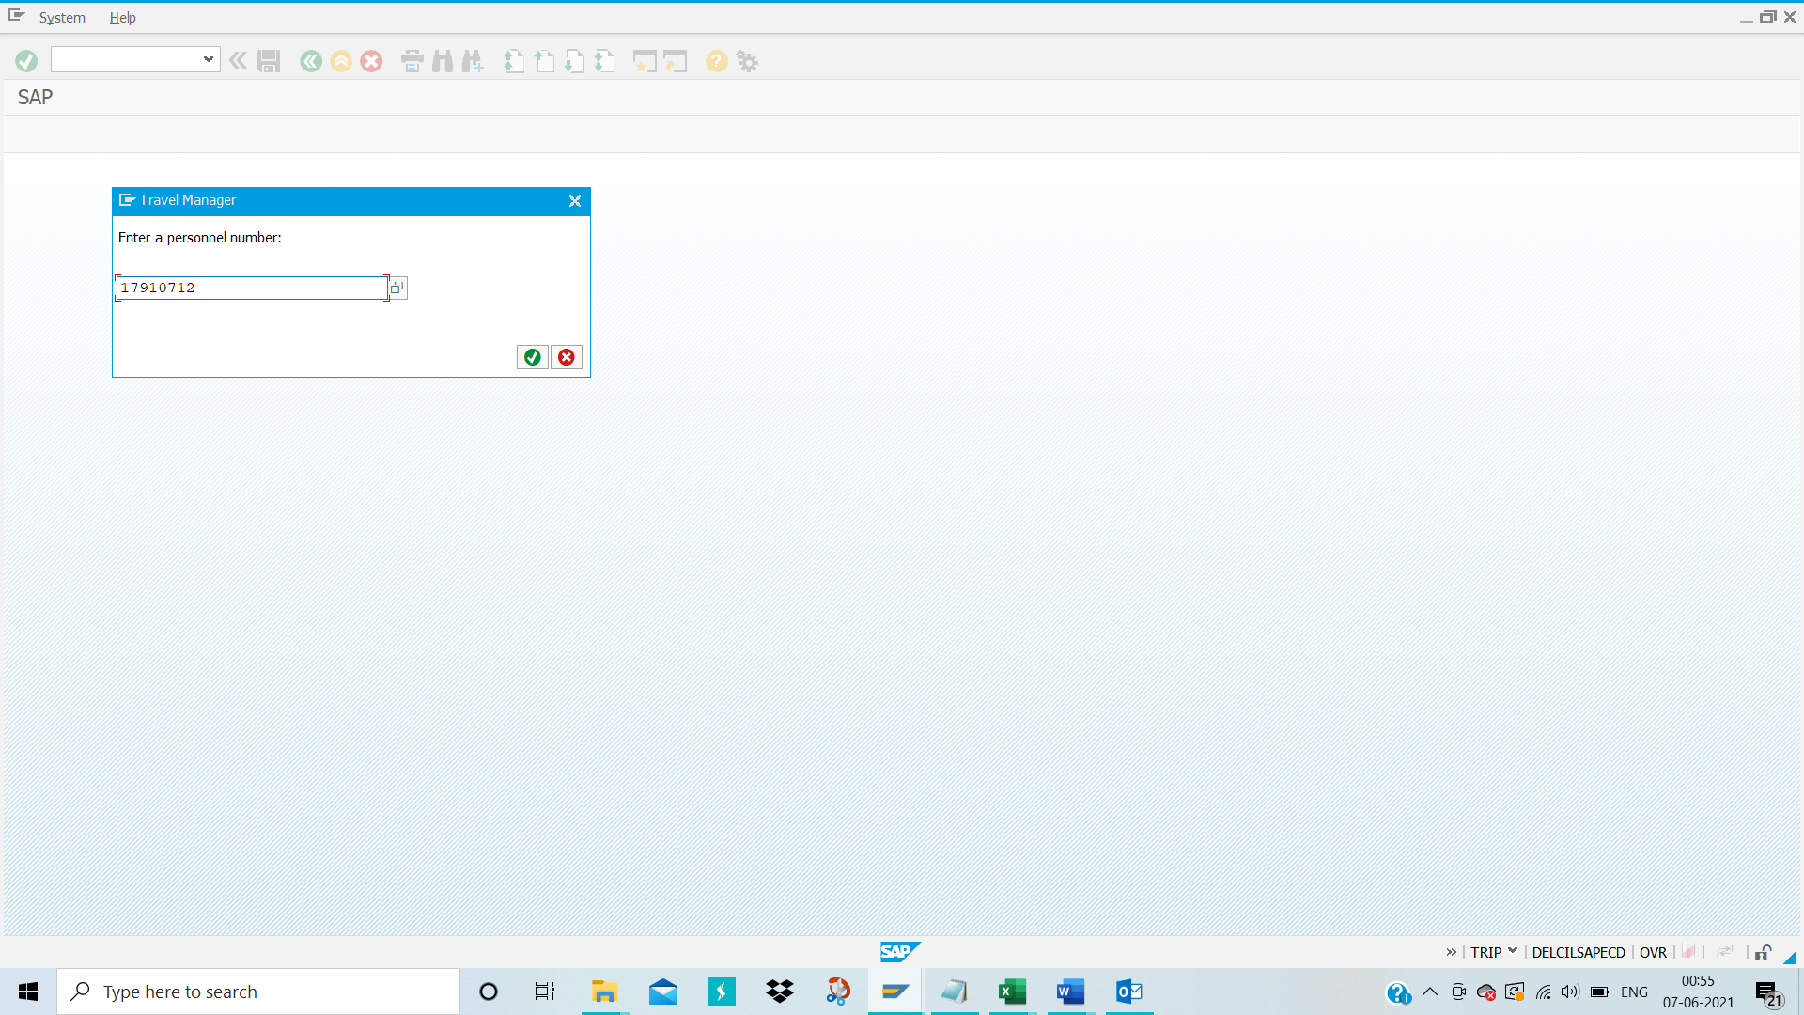
Click on tick mark icon as shown in the above snapshot

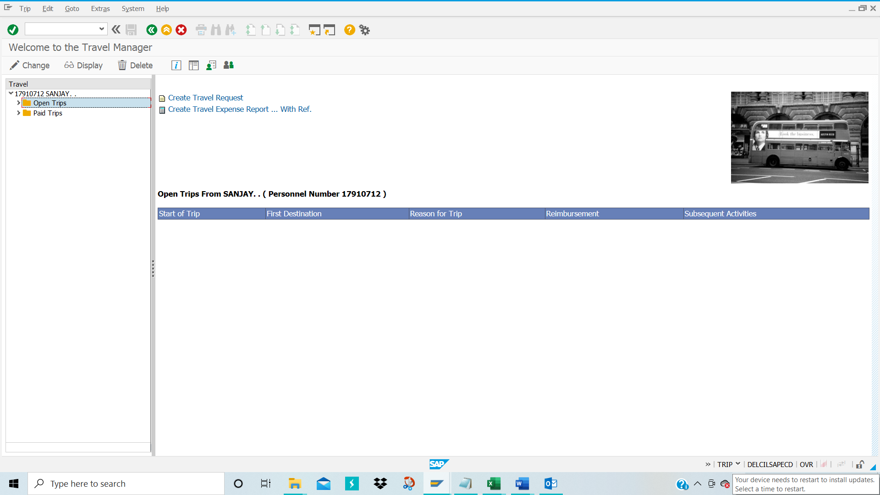
Click on ‘Create Travel Request’ option as shown in the above snapshot.
The below snapshot appears
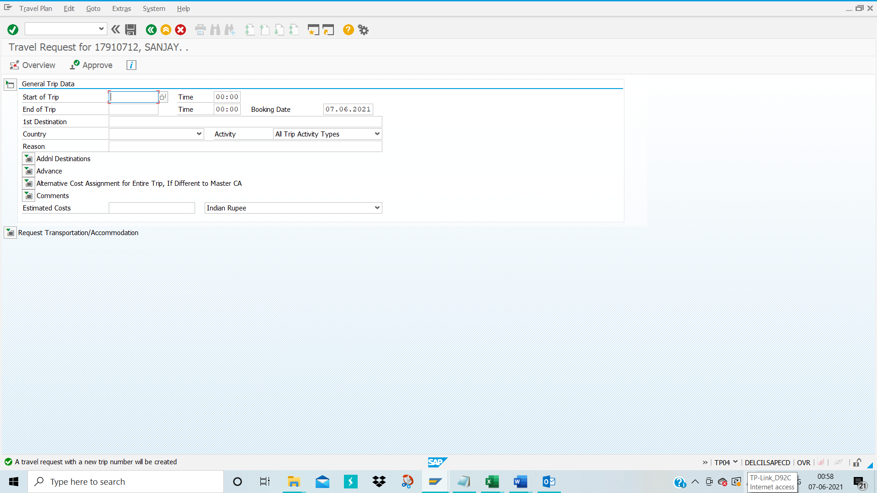
Here fill the details for ‘Start of Trip’ (Date on which trip starts), ’End of Trip’ (Date on which the trip ends), Start time of the trip, end time of the trip,1st Destination, country, Activity Type, and Reason for the trip. -
Addnl Destinations:
Click on Additional Destination if you are traveling to any other location from 1st Destination, Country code, Start Date of the trip and Start Time of the trip, Select reason for the trip and activity type.

Advance:
For requesting an advance, please click on ‘Advance’
Don’t select ’cash’ option as you will not be paid advance in cash

Alternative Cost Assignment for Entire Trip, If Different to Master CA
If you would like to charge your expenses to different cost centre other than cost centre available in employee’s organizational assignment infotype then you can fill the cost centre.
Comments:
If you would like to add any message to your manager for travel request approval, you can use this.
NOTE:TRAVEL BOOKING SERVICES IS OUTSIDE OF SAP
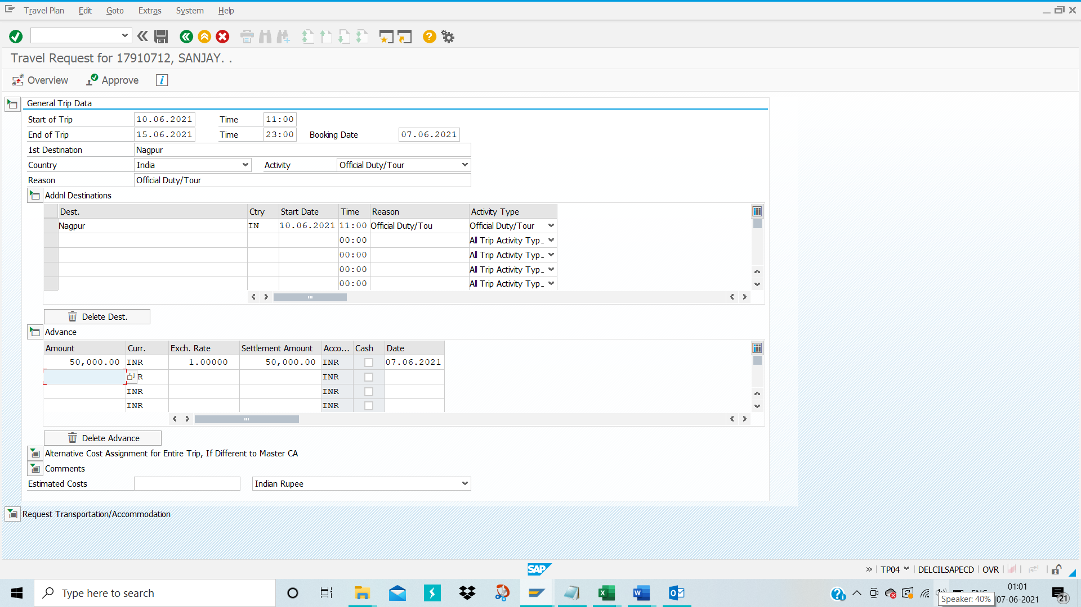

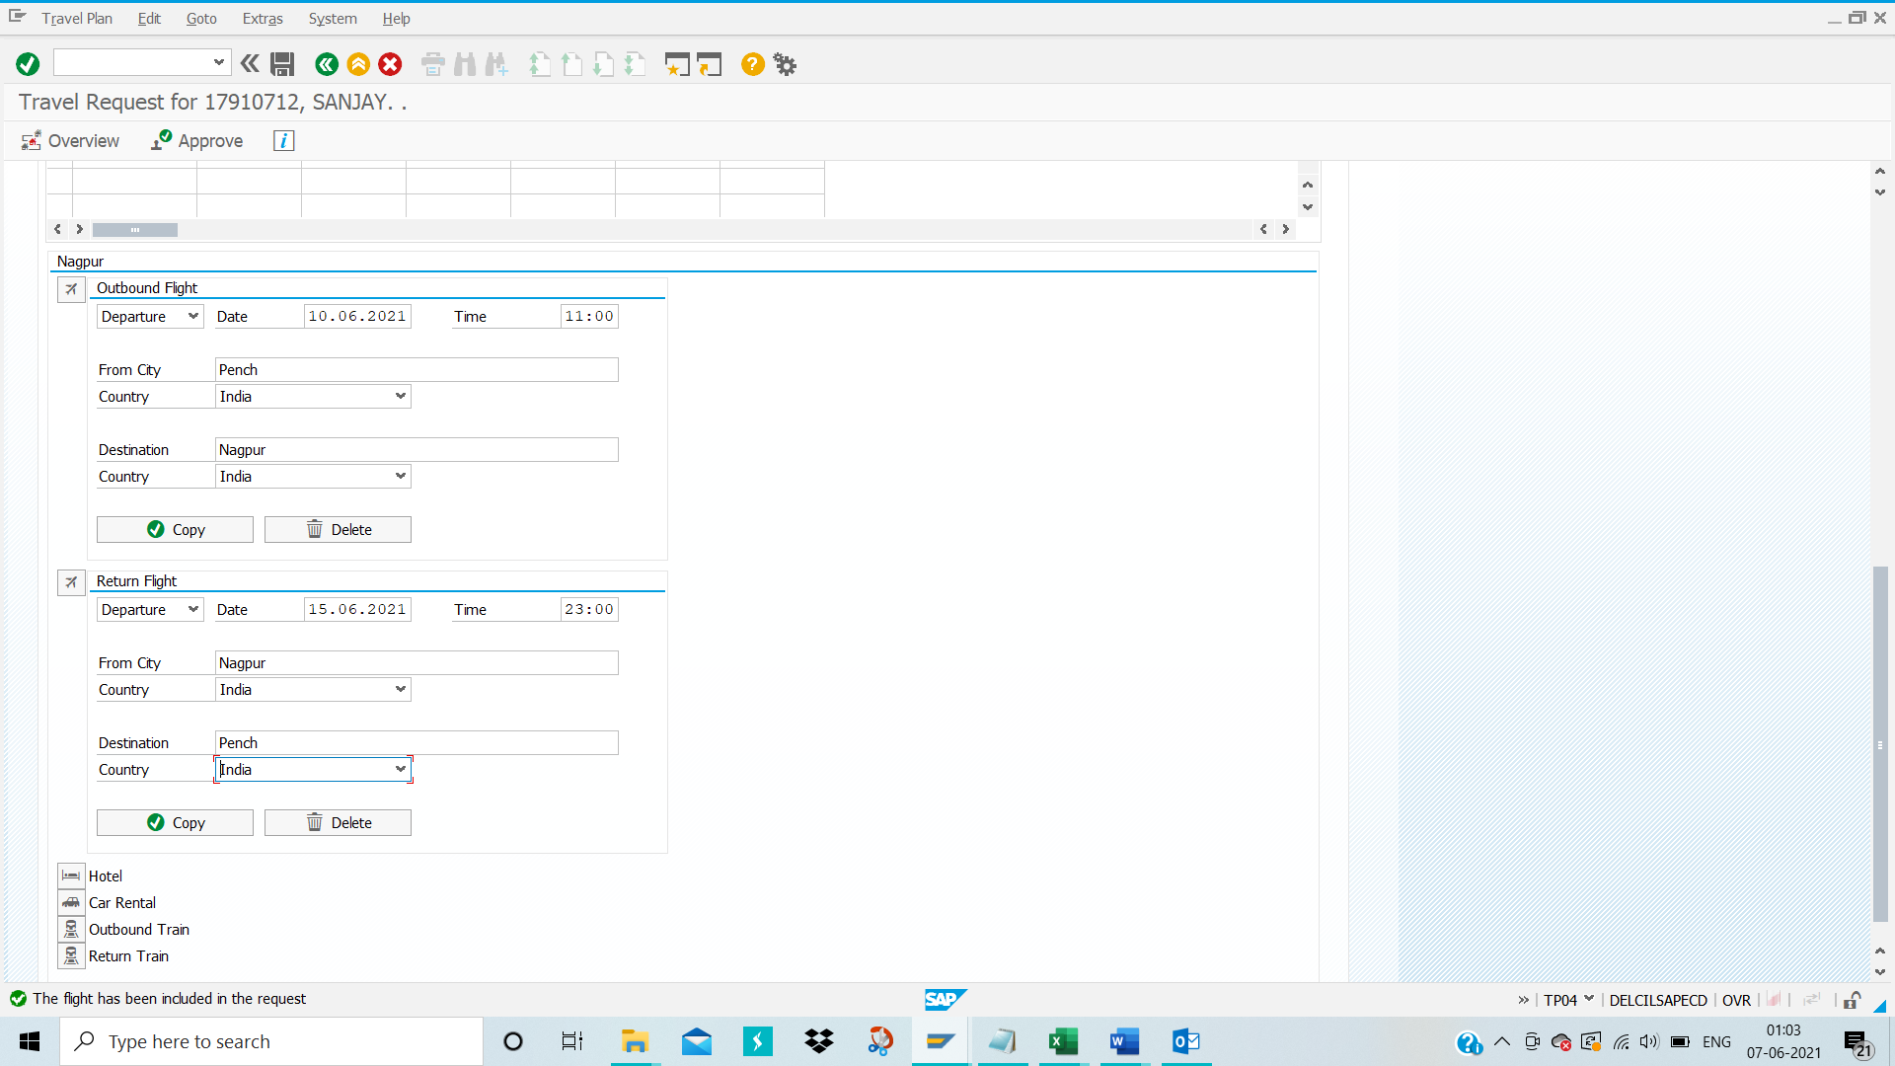

Upon successful creation of travel request, Click on the Save option then travel request number will be generated for the trip.
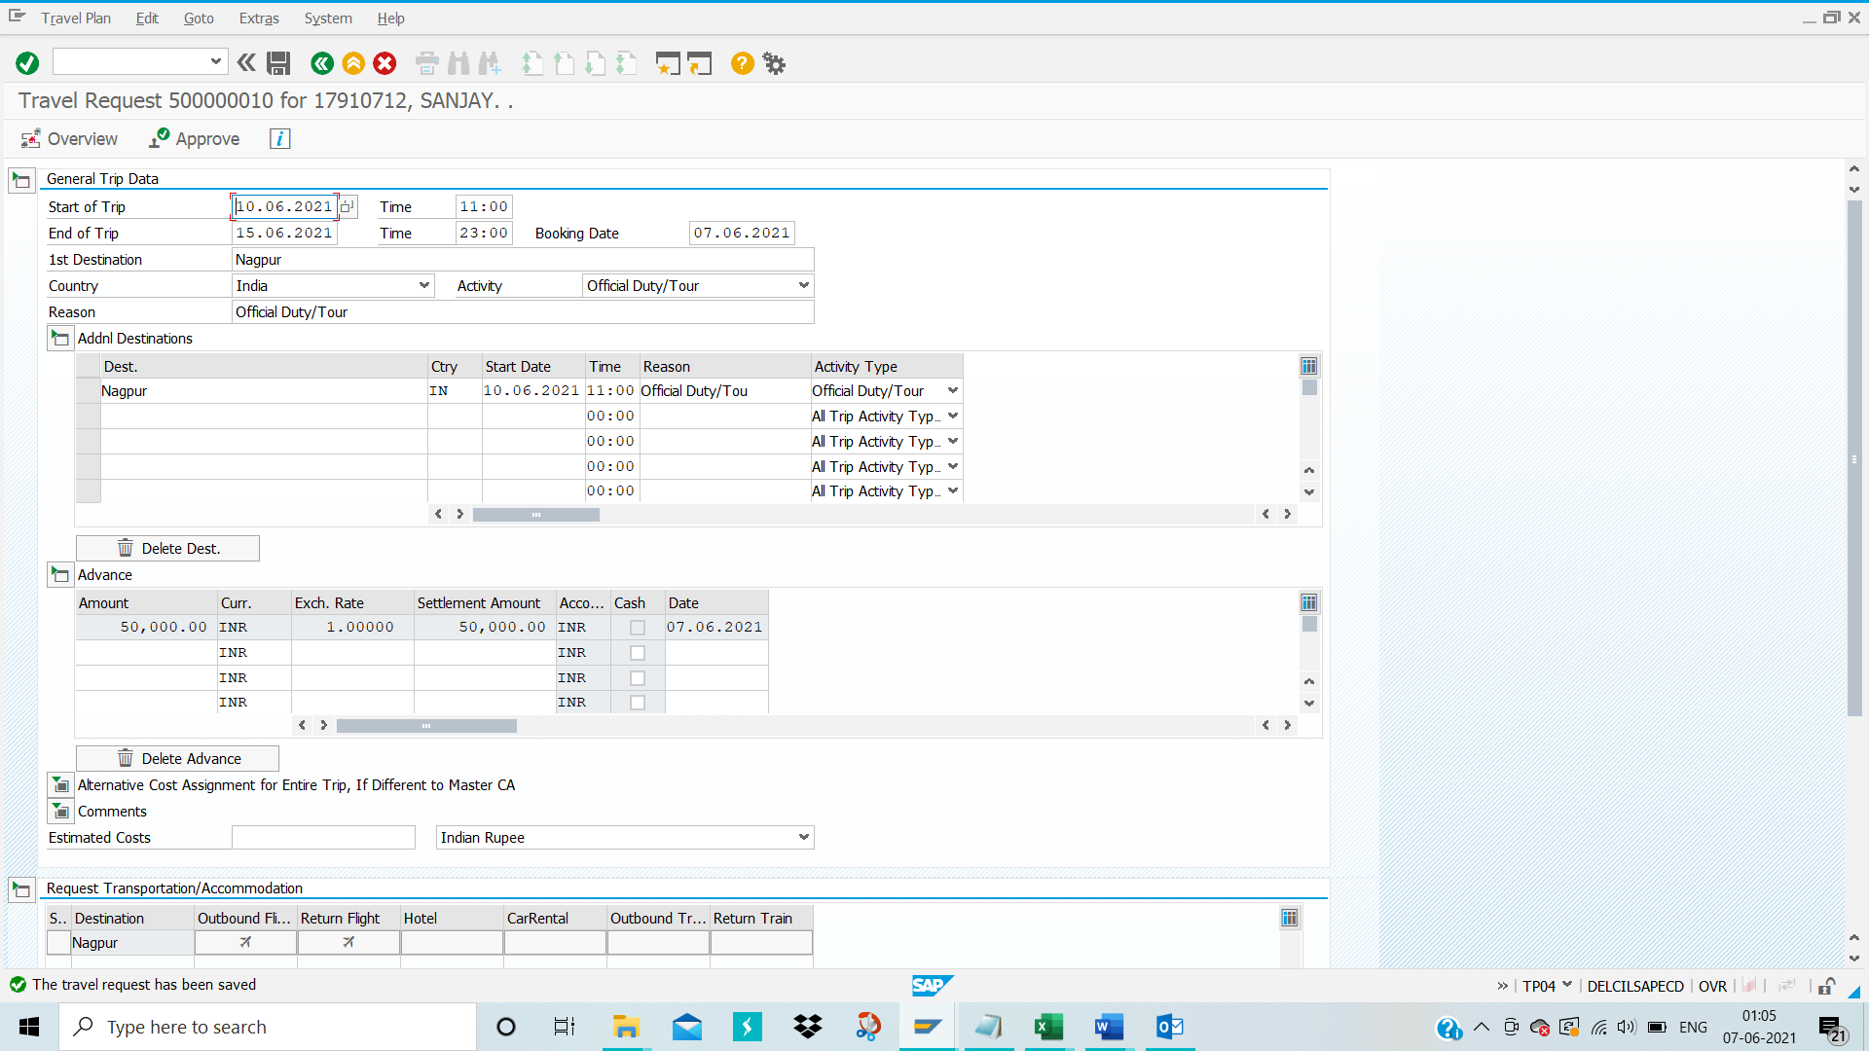
Here is the overview of the filled details for the travel request

Please completely come out of the TRIP screen

Then again enter TRIP in command bar and then select employee’s personnel number
Place cursor on the travel request as shown below and click on ‘Display’ option
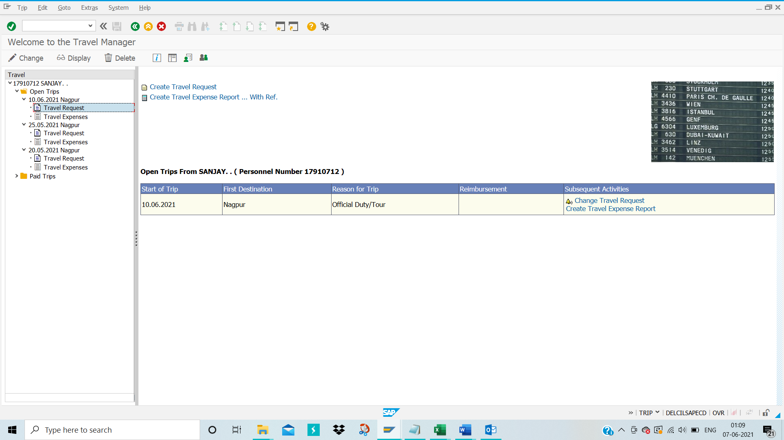
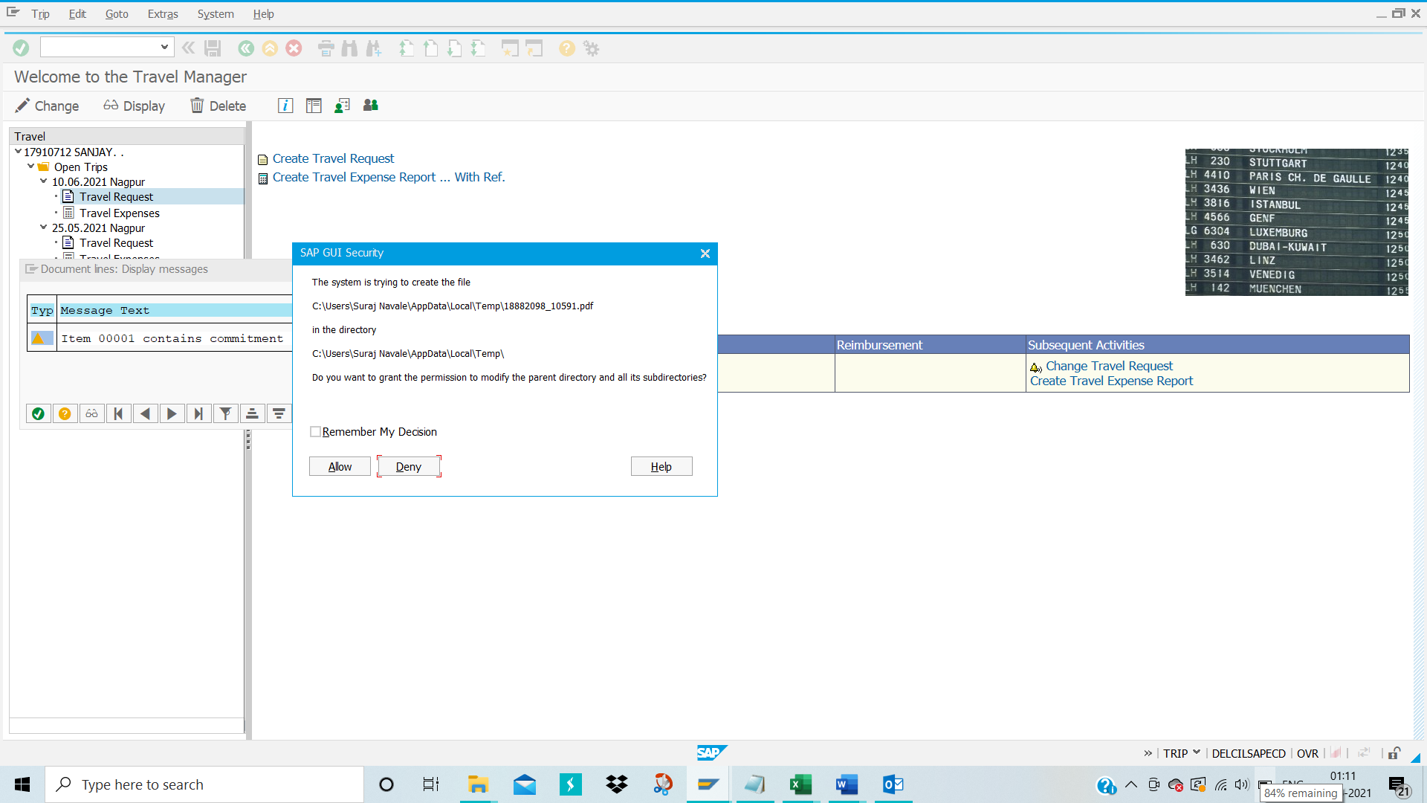
Click on ‘Allow’ option
Click on ‘Print’ option for printing the travel request for future reference
Click on ‘Save’ option for saving travel request form into your desktop

Approve Travel Request
TCODE-PR05
Enter TCODE-PR05 in the command bar
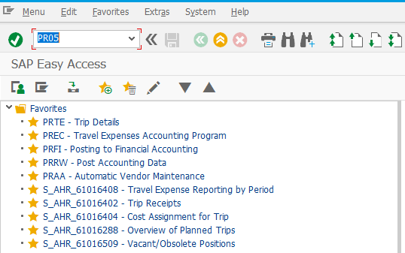
Press ‘Enter’ key from your keyboard

Manually input Employee’s Personnel number and then press ‘Enter’ from your keyboard
The below screen appears

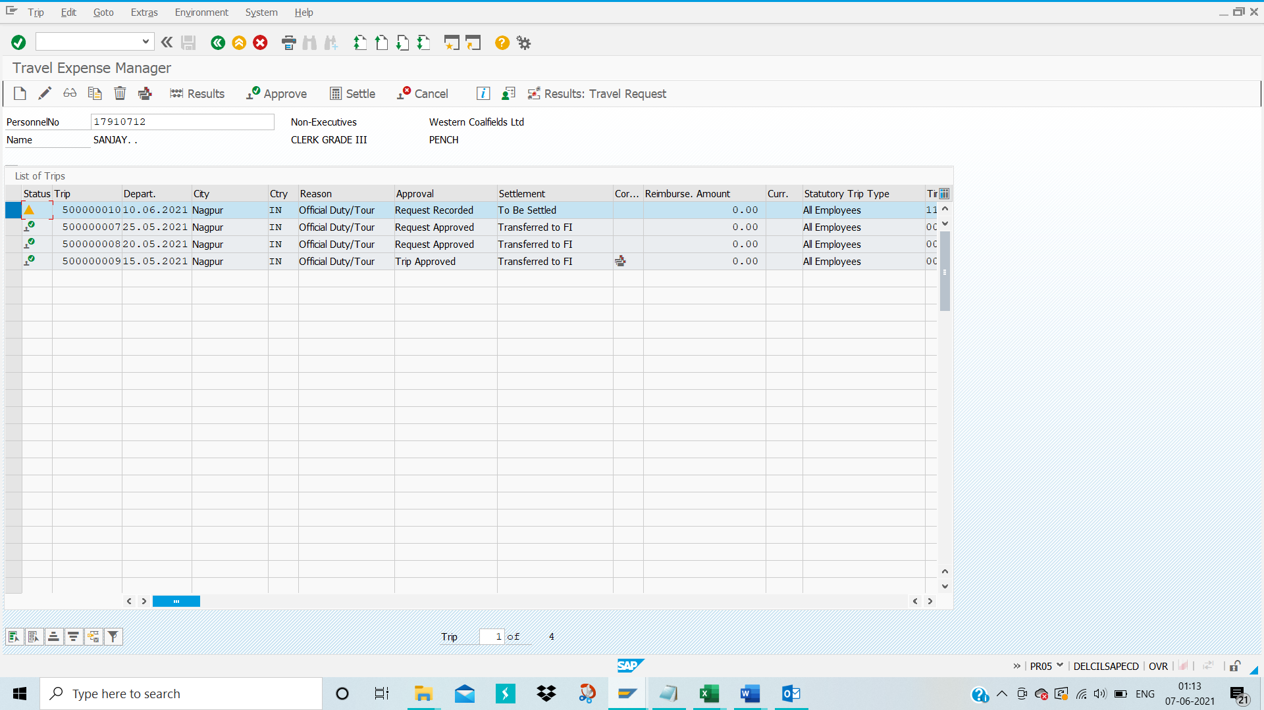
Select travel request line item and then click on ‘Approve’ for approving the travel request

Upon approval, Approval status is changed from ‘Request Recorded’ to ‘Request approved’ as shown in the below snapshot.
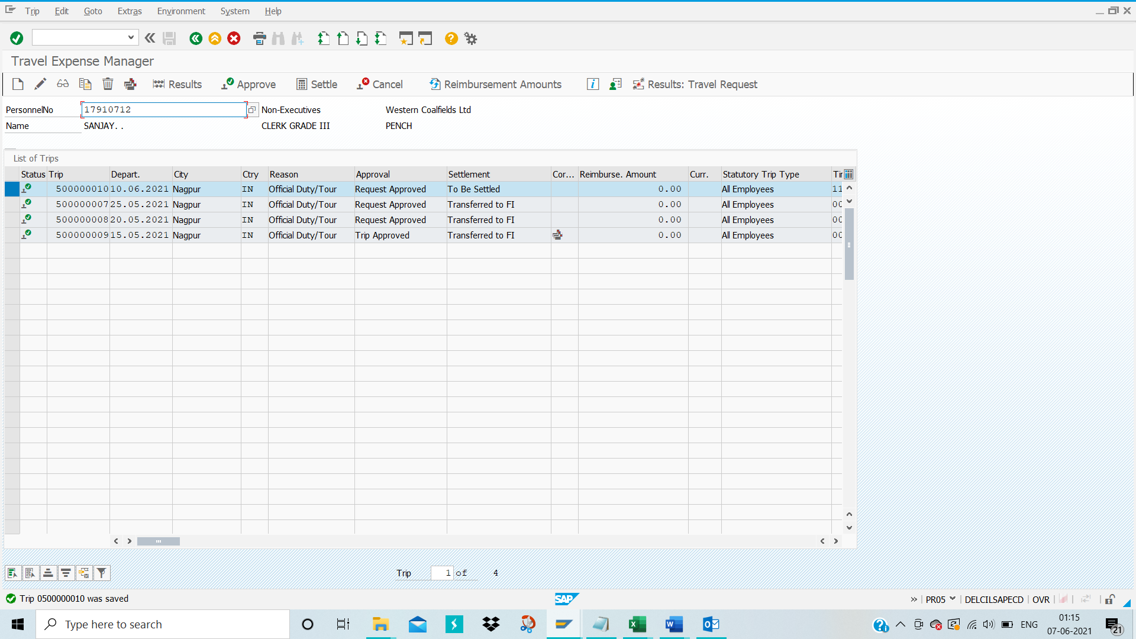

Approve Travel Advance: -
TCODE-PR03
Enter TCODE-PR03 in the command bar and then press ‘Enter’ from the keyboard
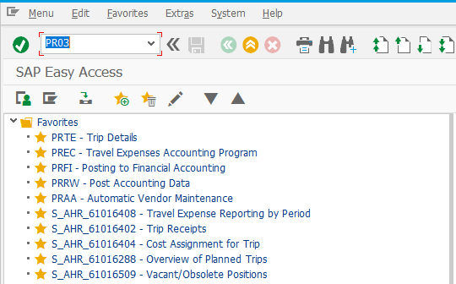
The below screen appears
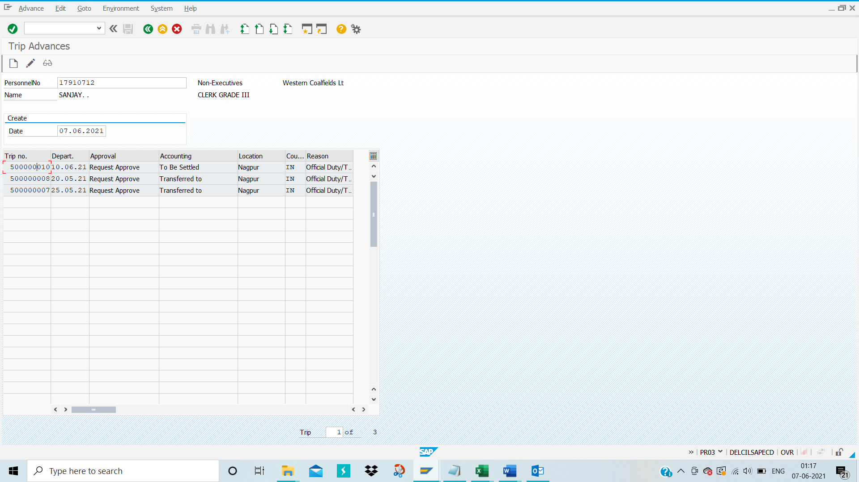
Click on change(pencil) icon for approving the travel advance

Then below screen will appears
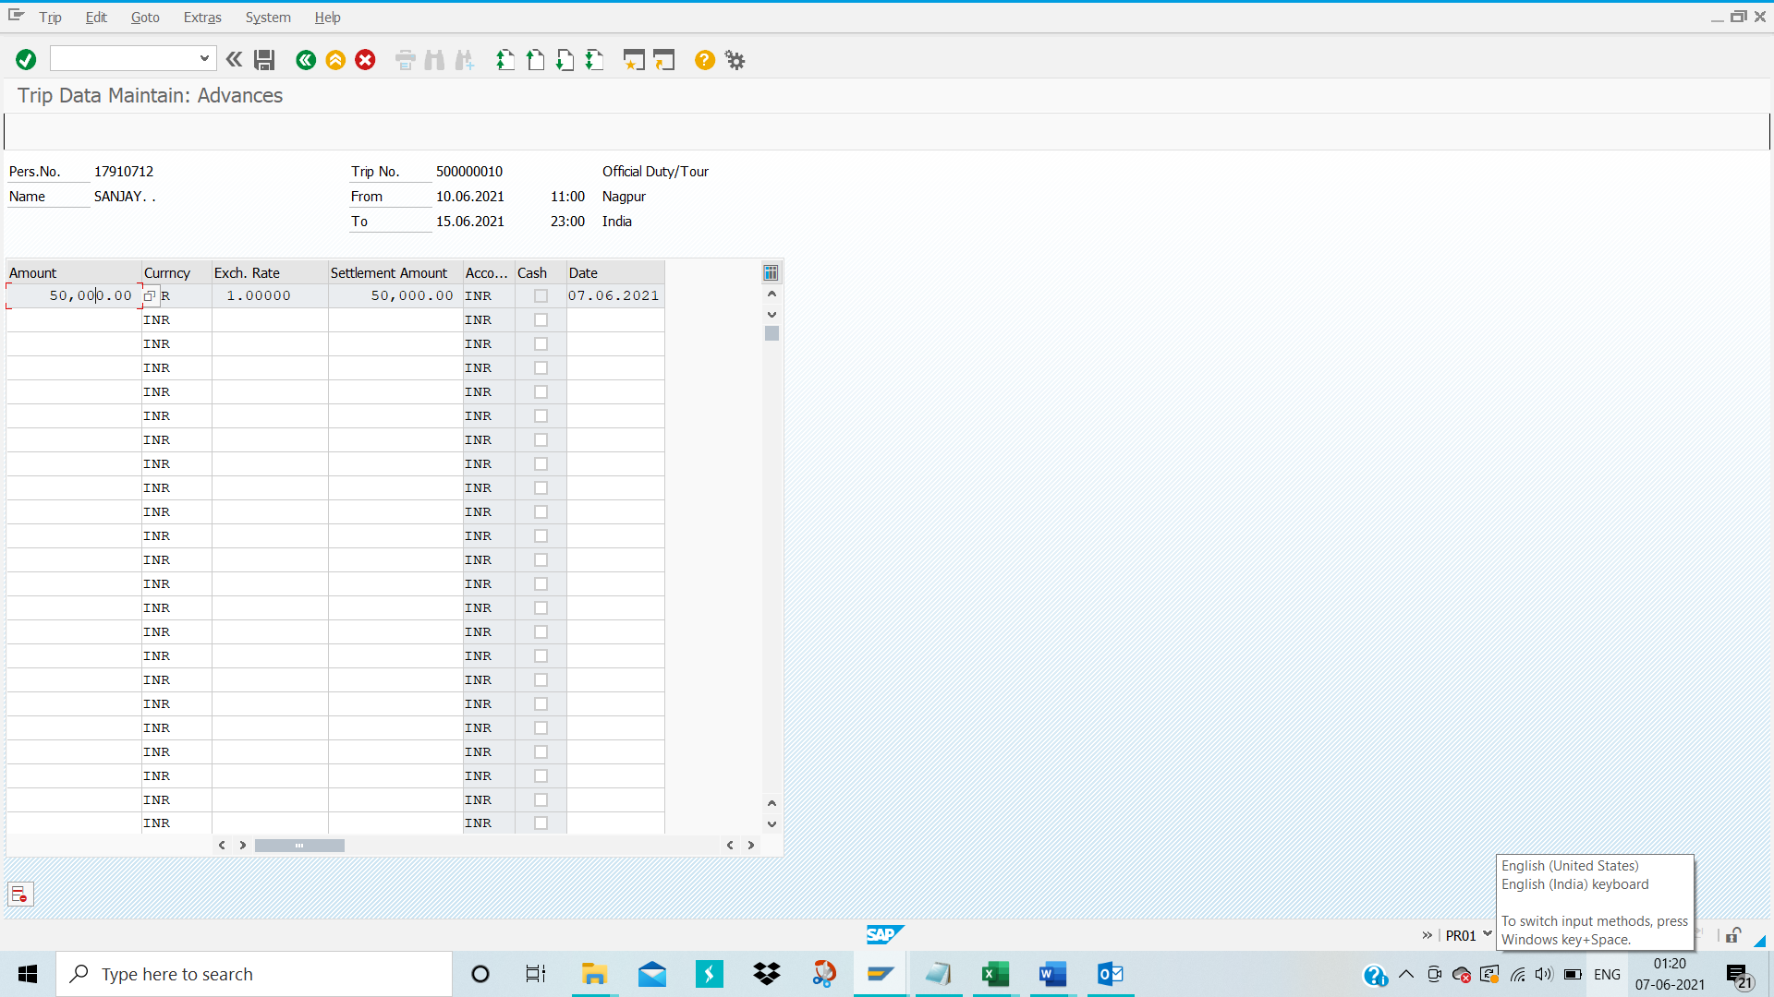
Click on ‘Save’ icon
The below screen appears
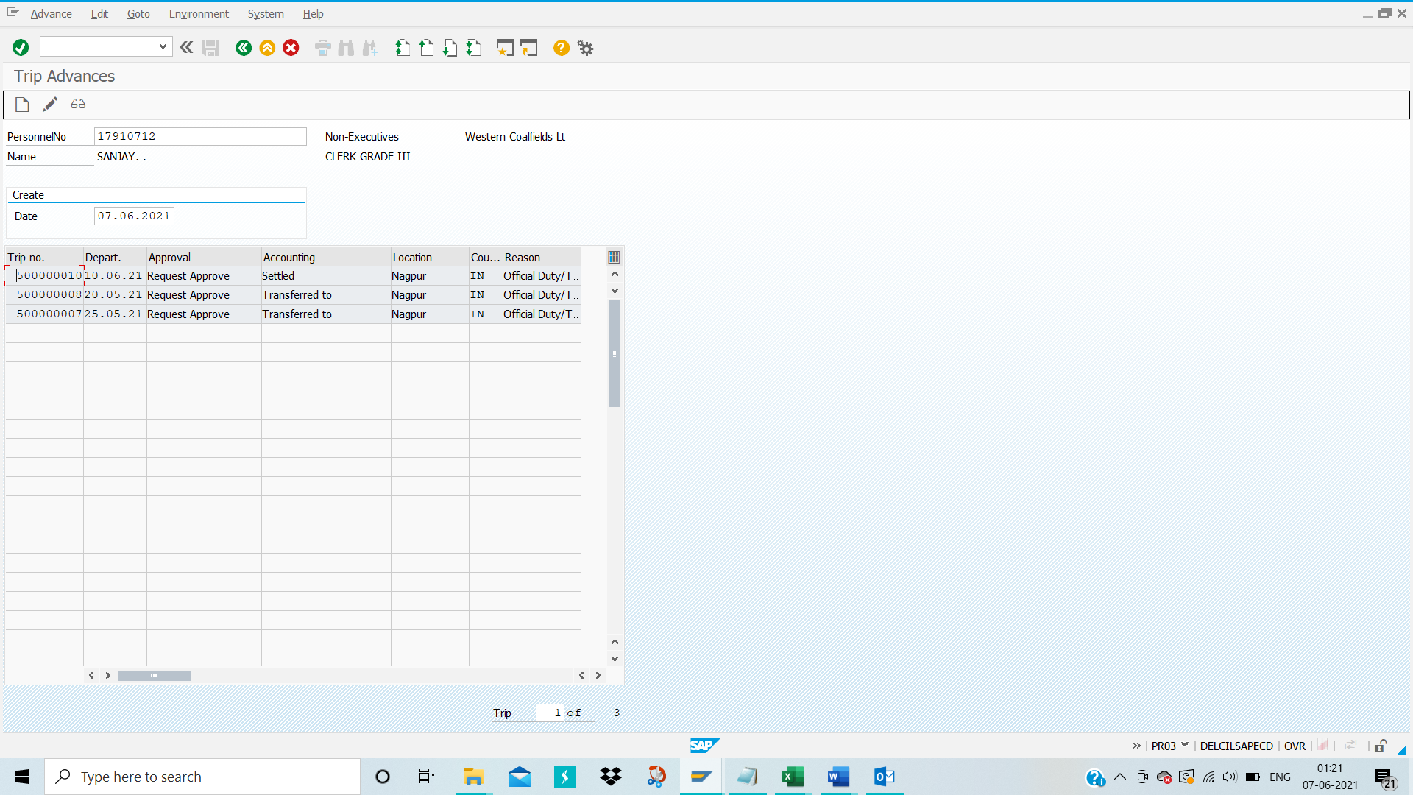
In the above screenshot, Accounting Status is changed from ‘To Be Settled’ to ‘Settled’

Create Posting Run:
TCODE-PRFI
Enter TCODE-PRFI in the command bar and then press enter
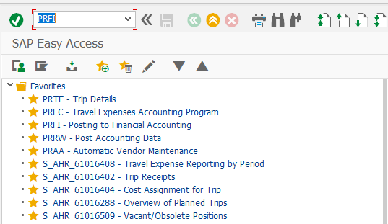

Below screen appears

Please fill the data for Payroll area, Personnel number and Trip Number
Please select ‘Trips’
Please deselect ‘Separation Allowances’
Please choose ‘Posting Run as simulation’
Please ‘choose incorrect CO objects’
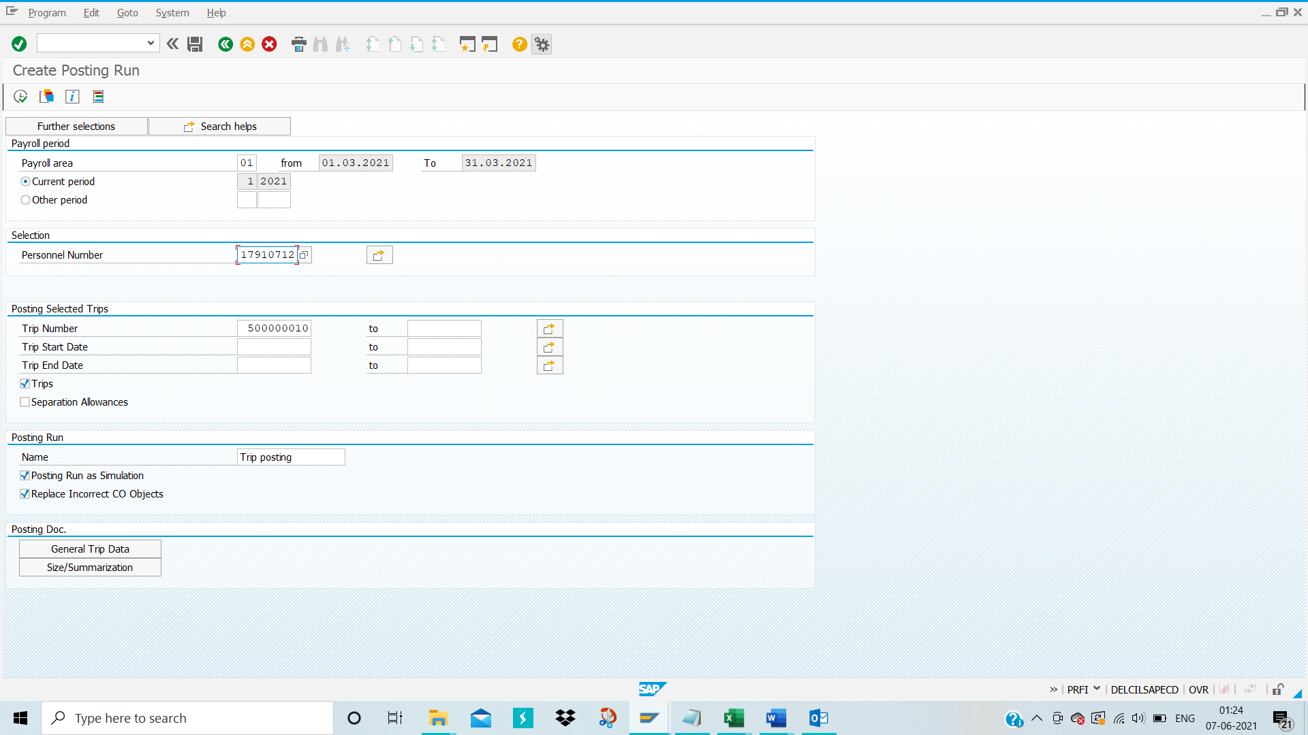
Please click on ‘Execute’ icon
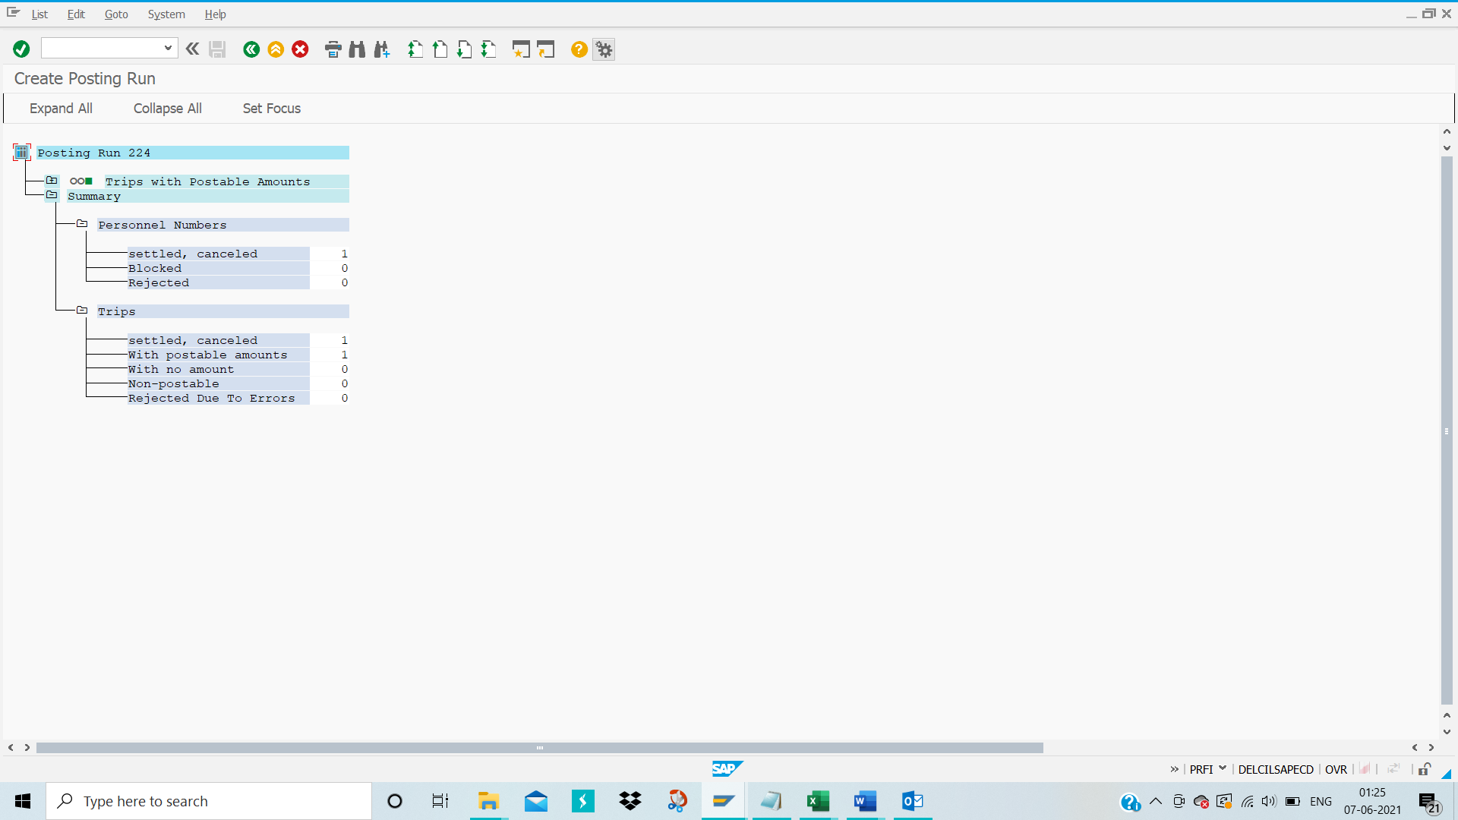
Please click on ‘+ Trips with postable amounts’ for expanding posting run
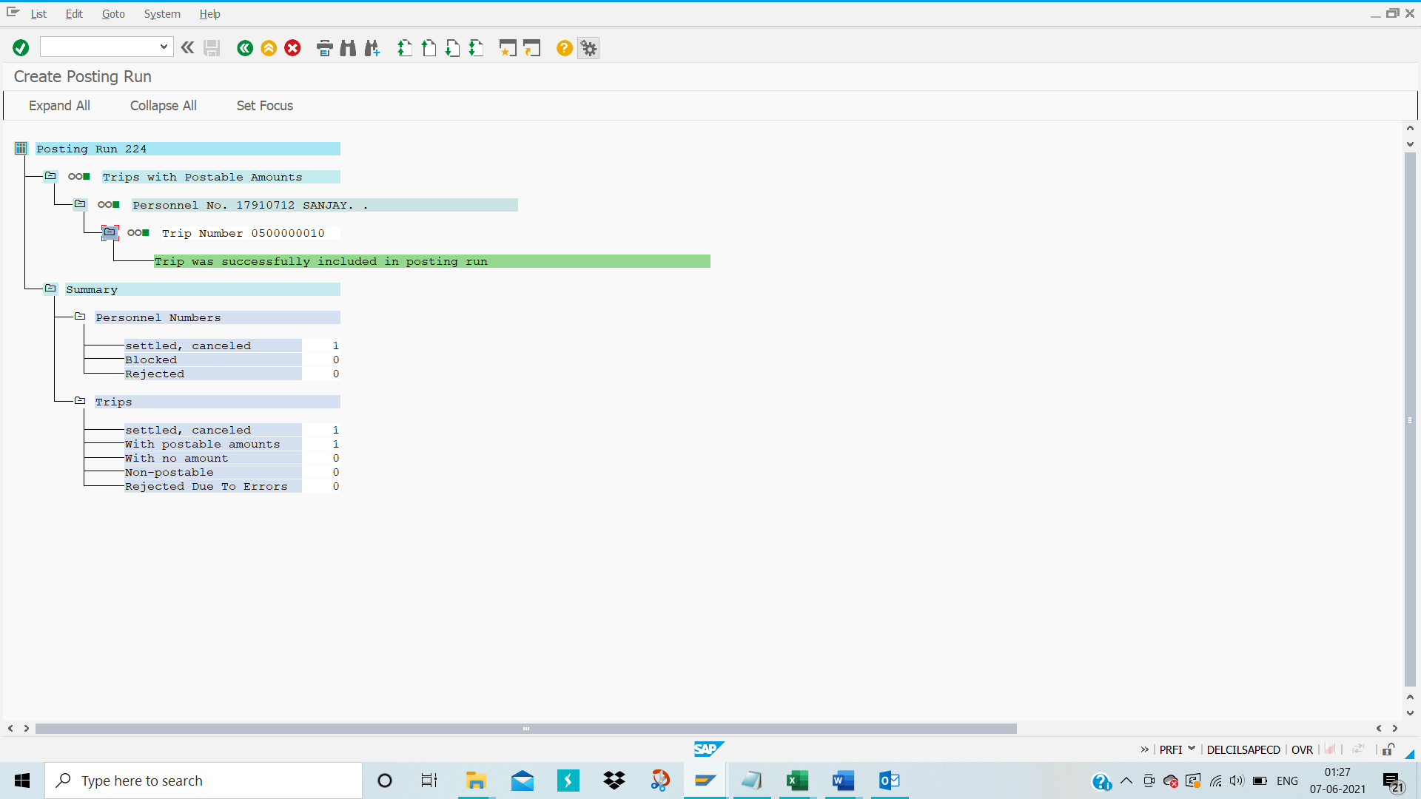
Now unselect ‘Posting Run as simulation’ and then execute
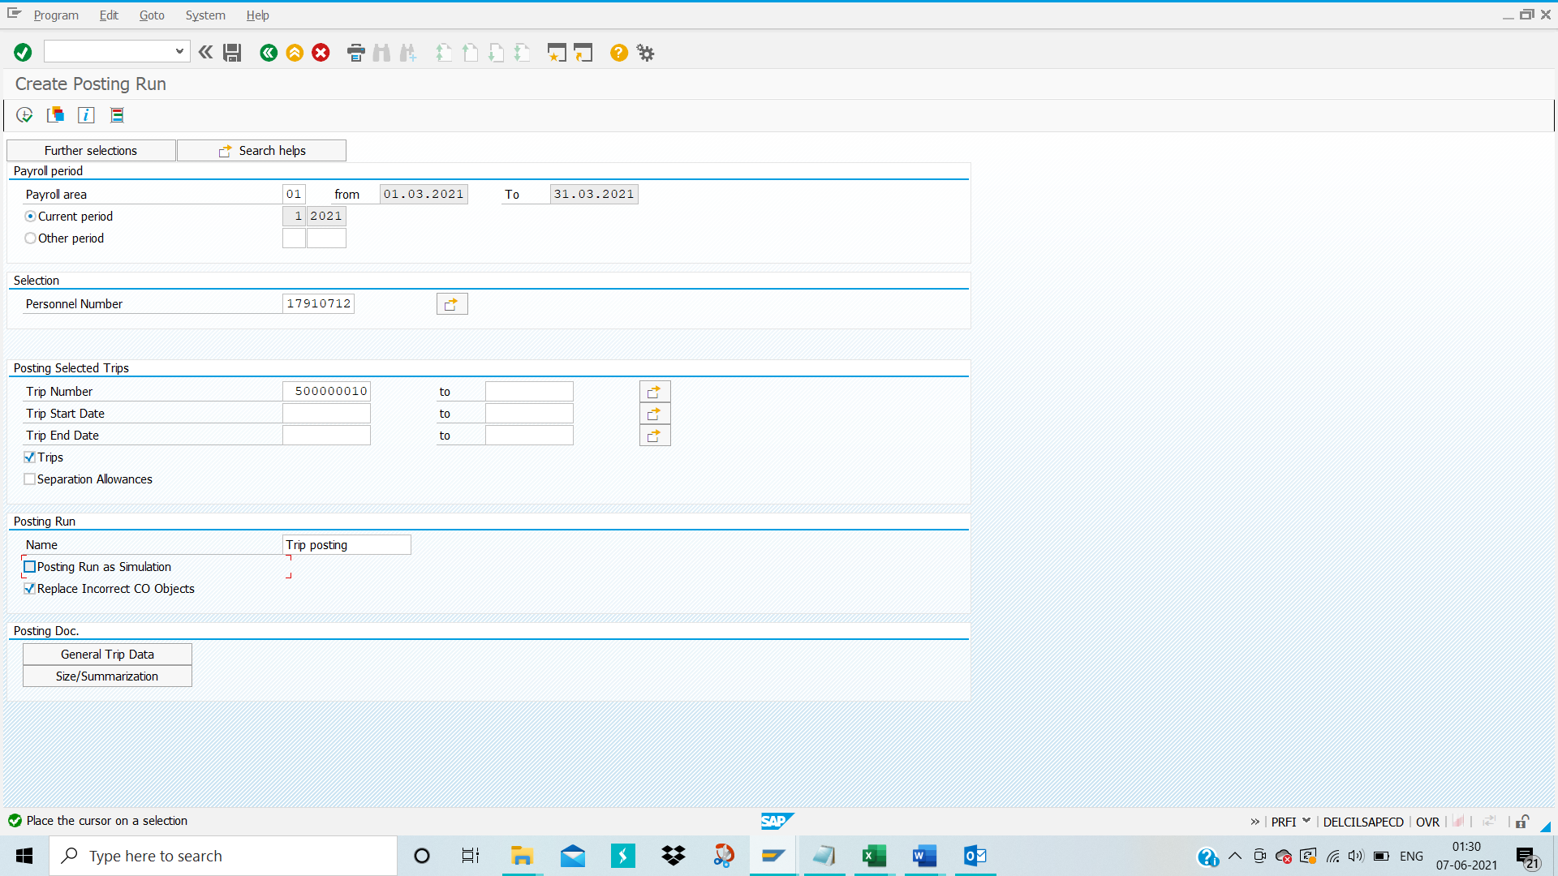
Below screen appears
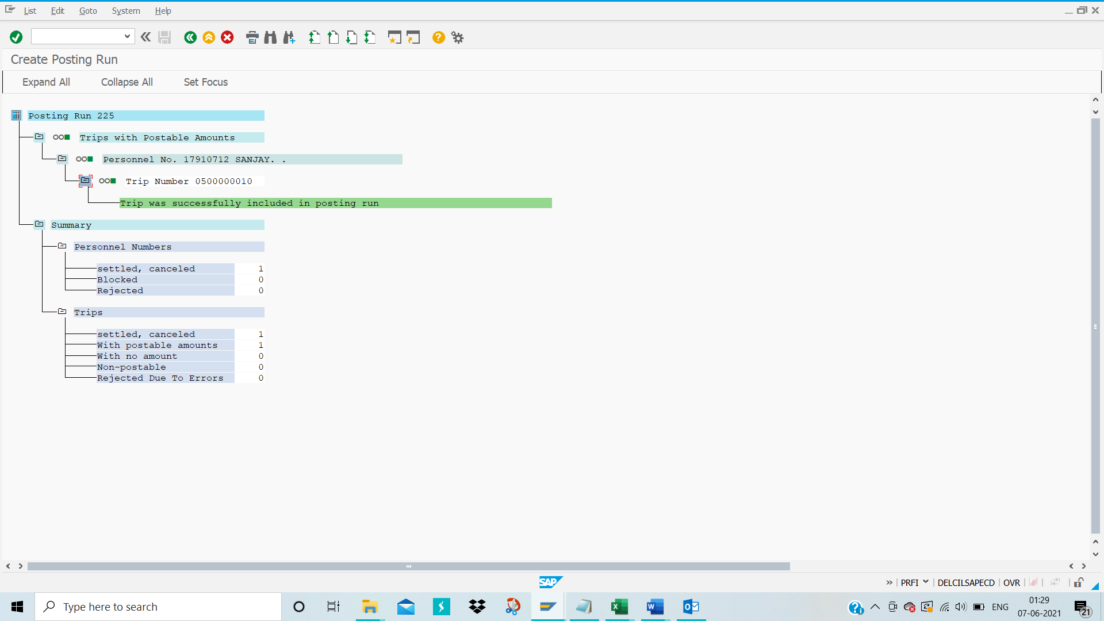

Posting Run Management:
TCODE-PRRW
Enter TCODE-PRRW in the command bar and then press enter
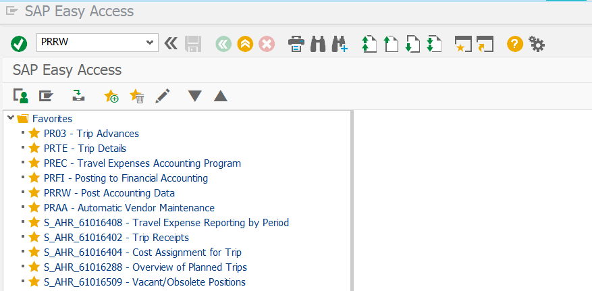
Below screen will appear
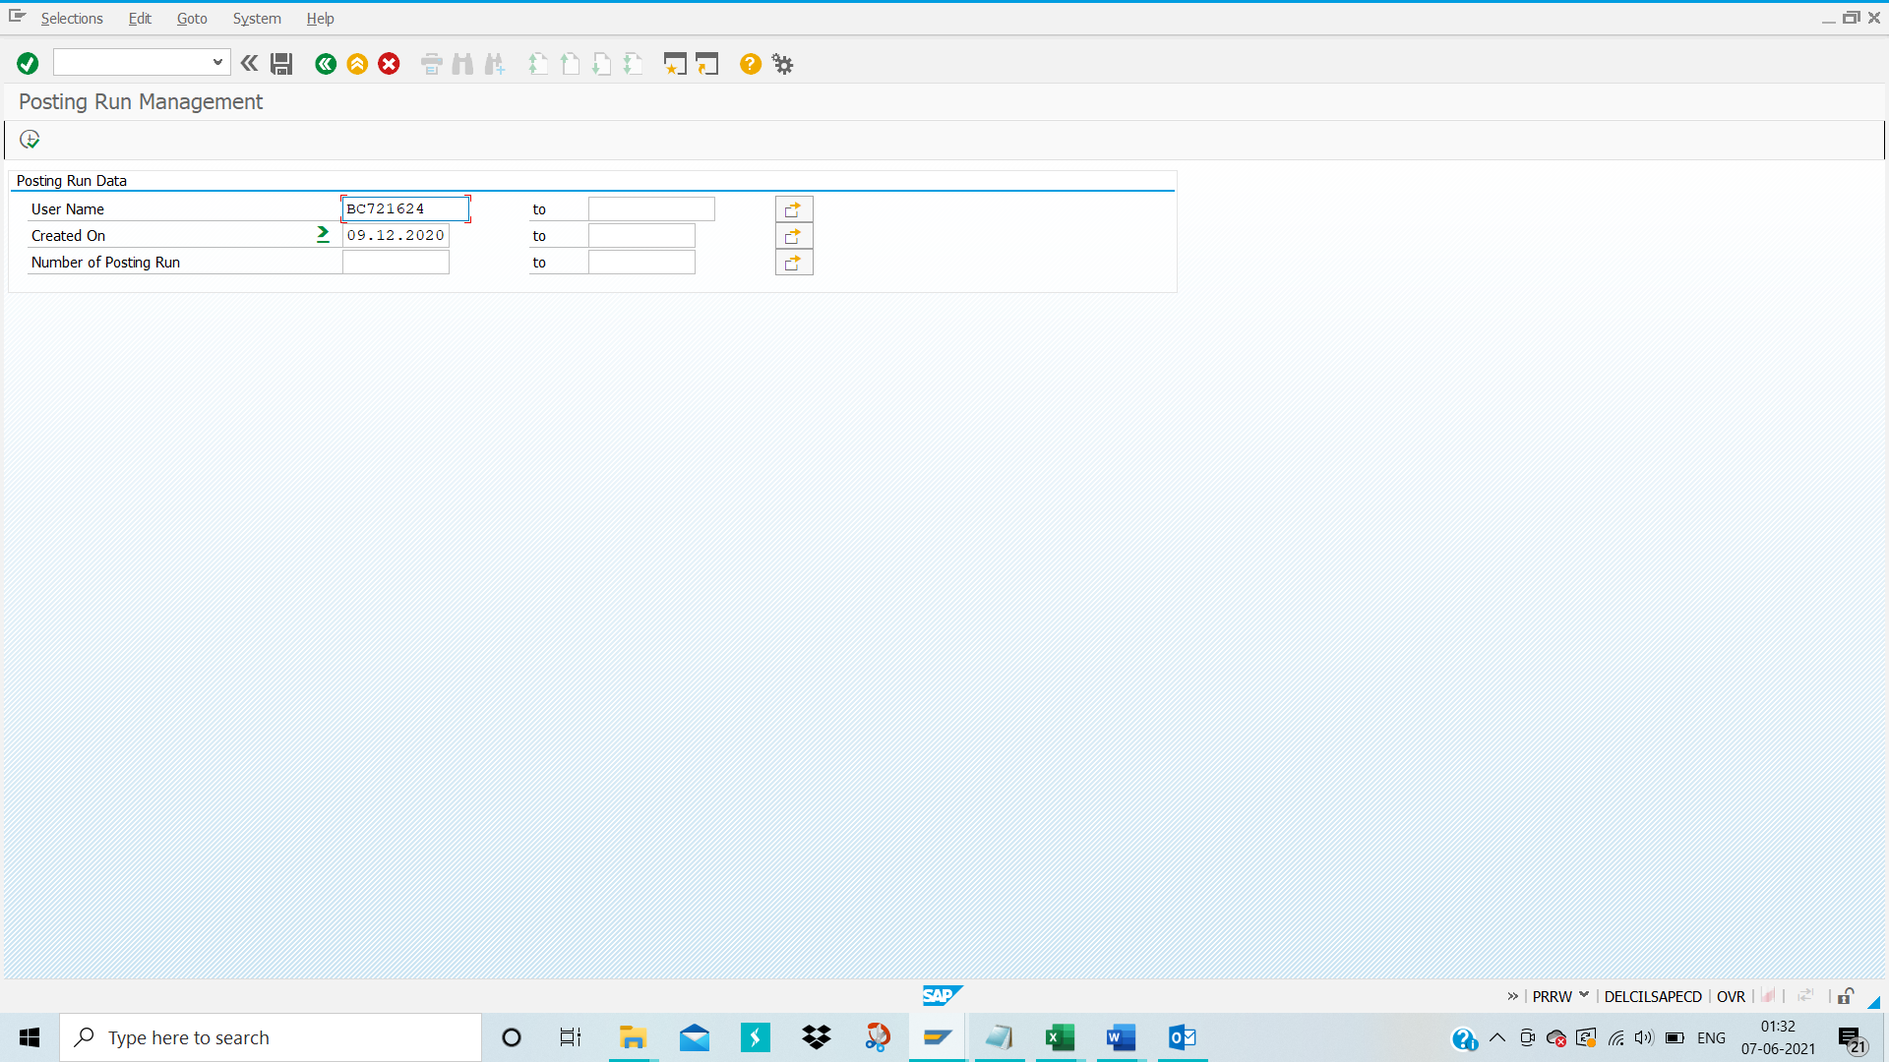
Execute
In SI row it is blank 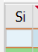 it means Actual Posting
In SI row it is arrow 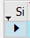 it means simulation Posting
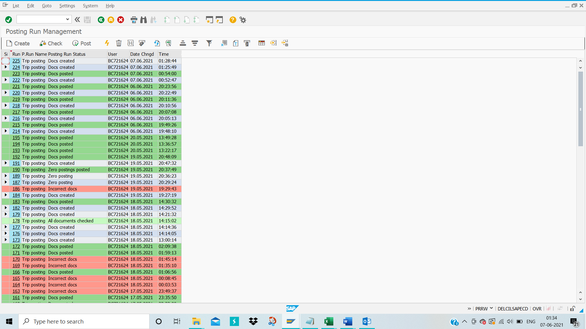
Select the Trip by clicking from SI row blank option then Click on ‘Check’ option to view the posting run document
The below screen appears
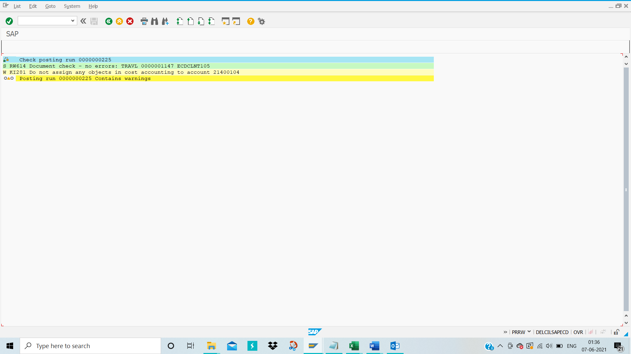
Click on the back green button.
Below Screen appears
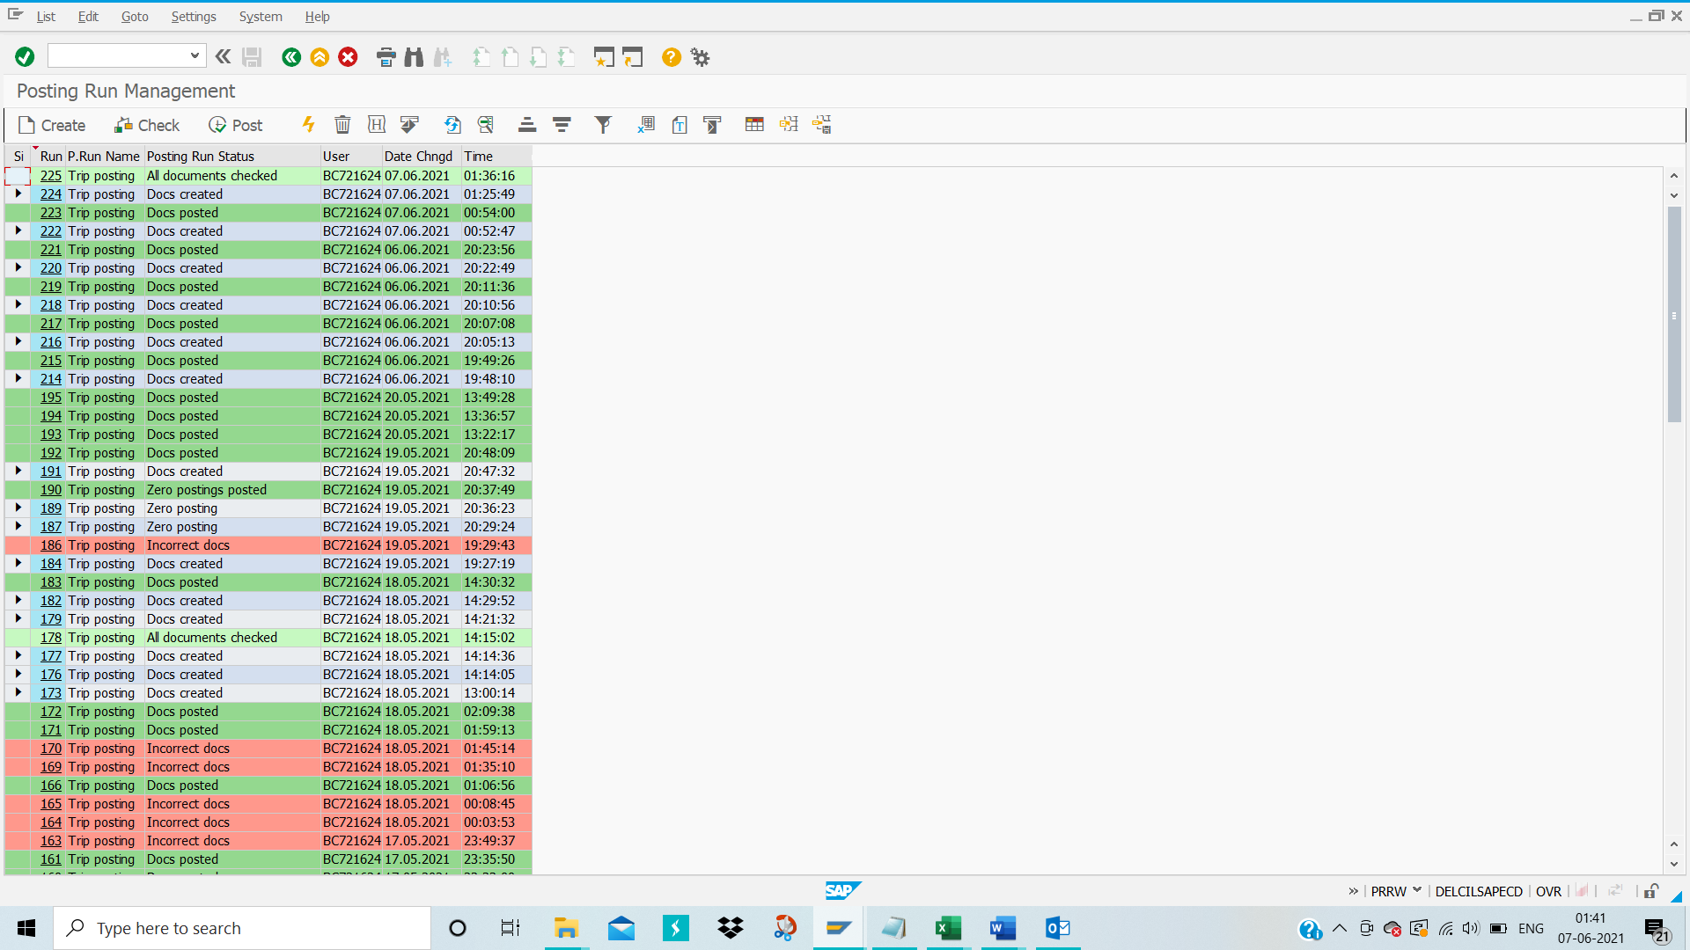
The posting run status changed from Docs created to All documents checked.
Select the row and click on “Post”
Below pop up will show “Run TR 0000000225 Post”
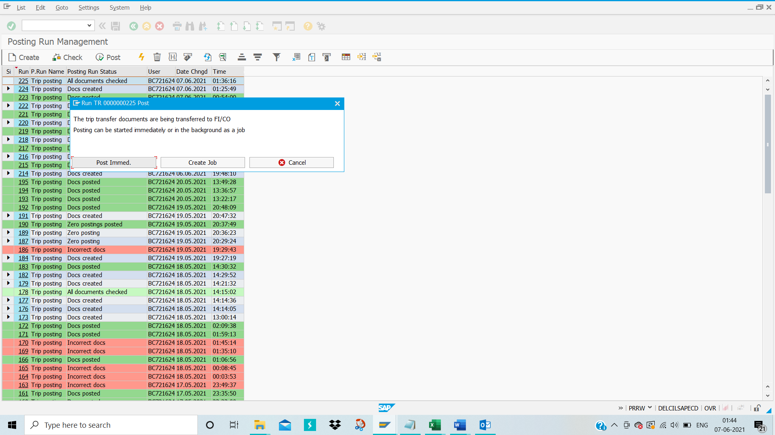
Click on the “Post Immed”
Then below screen appears
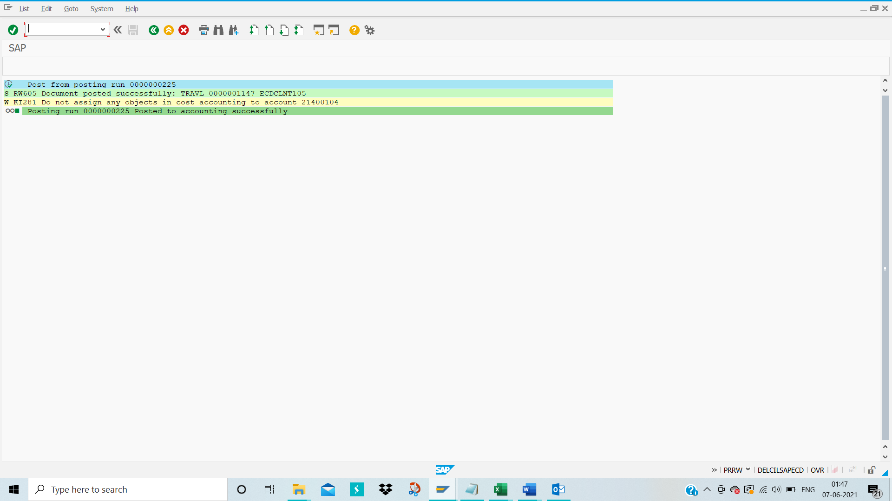

Travel Expenses Report:
TCODE- TRIP
Enter TCODE- TRIP in the command bar and then press enter
Manually specify employee’s personnel number as shown in the below snapshot.

Click on tick mark icon as shown in the above snapshot
Below screen will appear

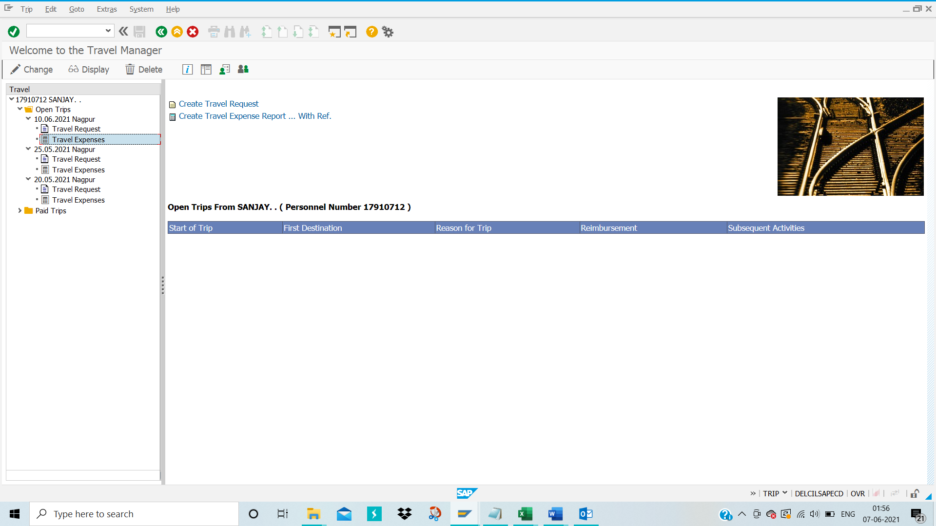
Select the Travel expenses option and Click on “Change” Button
Below pop up will display:
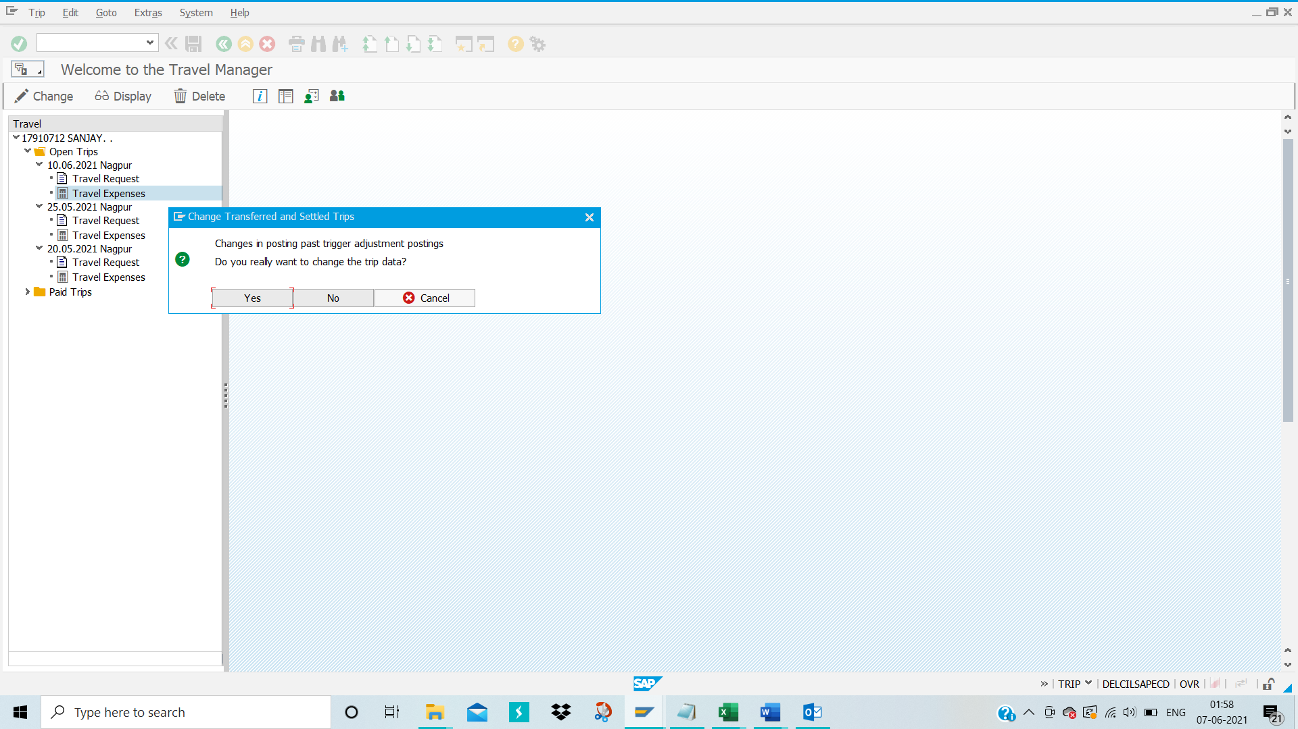
Click on “Yes” option
Then below Travel Expenses screen will appear

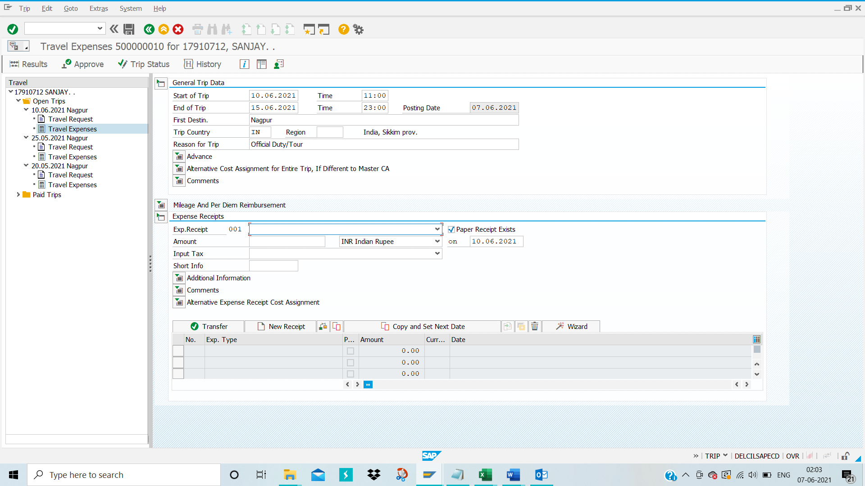
Fill up the “Expenses Receipts 001” by clicking on down arrow
Then fill up the Amount and click on transfer Button
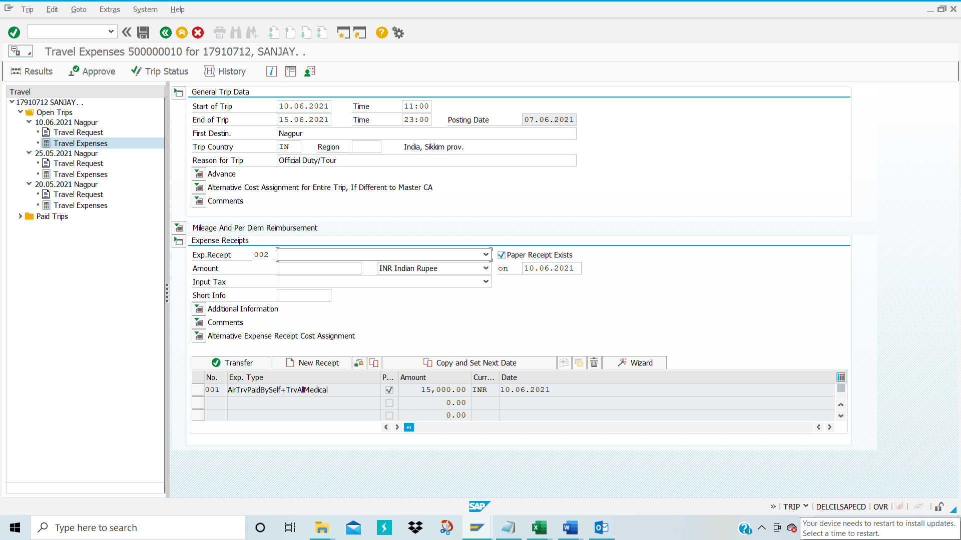
Then “Expenses Receipt 001” will get added and can add more expenses.

Click on 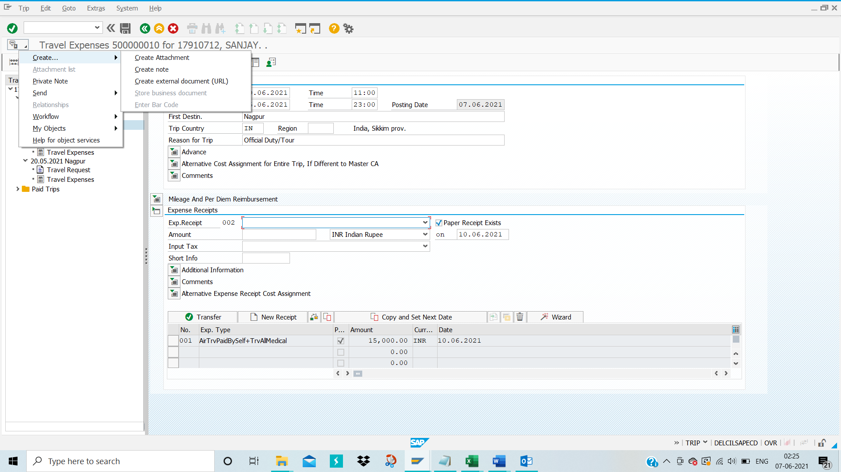attachment logo also can attach the receipts in Create attachment below screen
Click on Save Button .

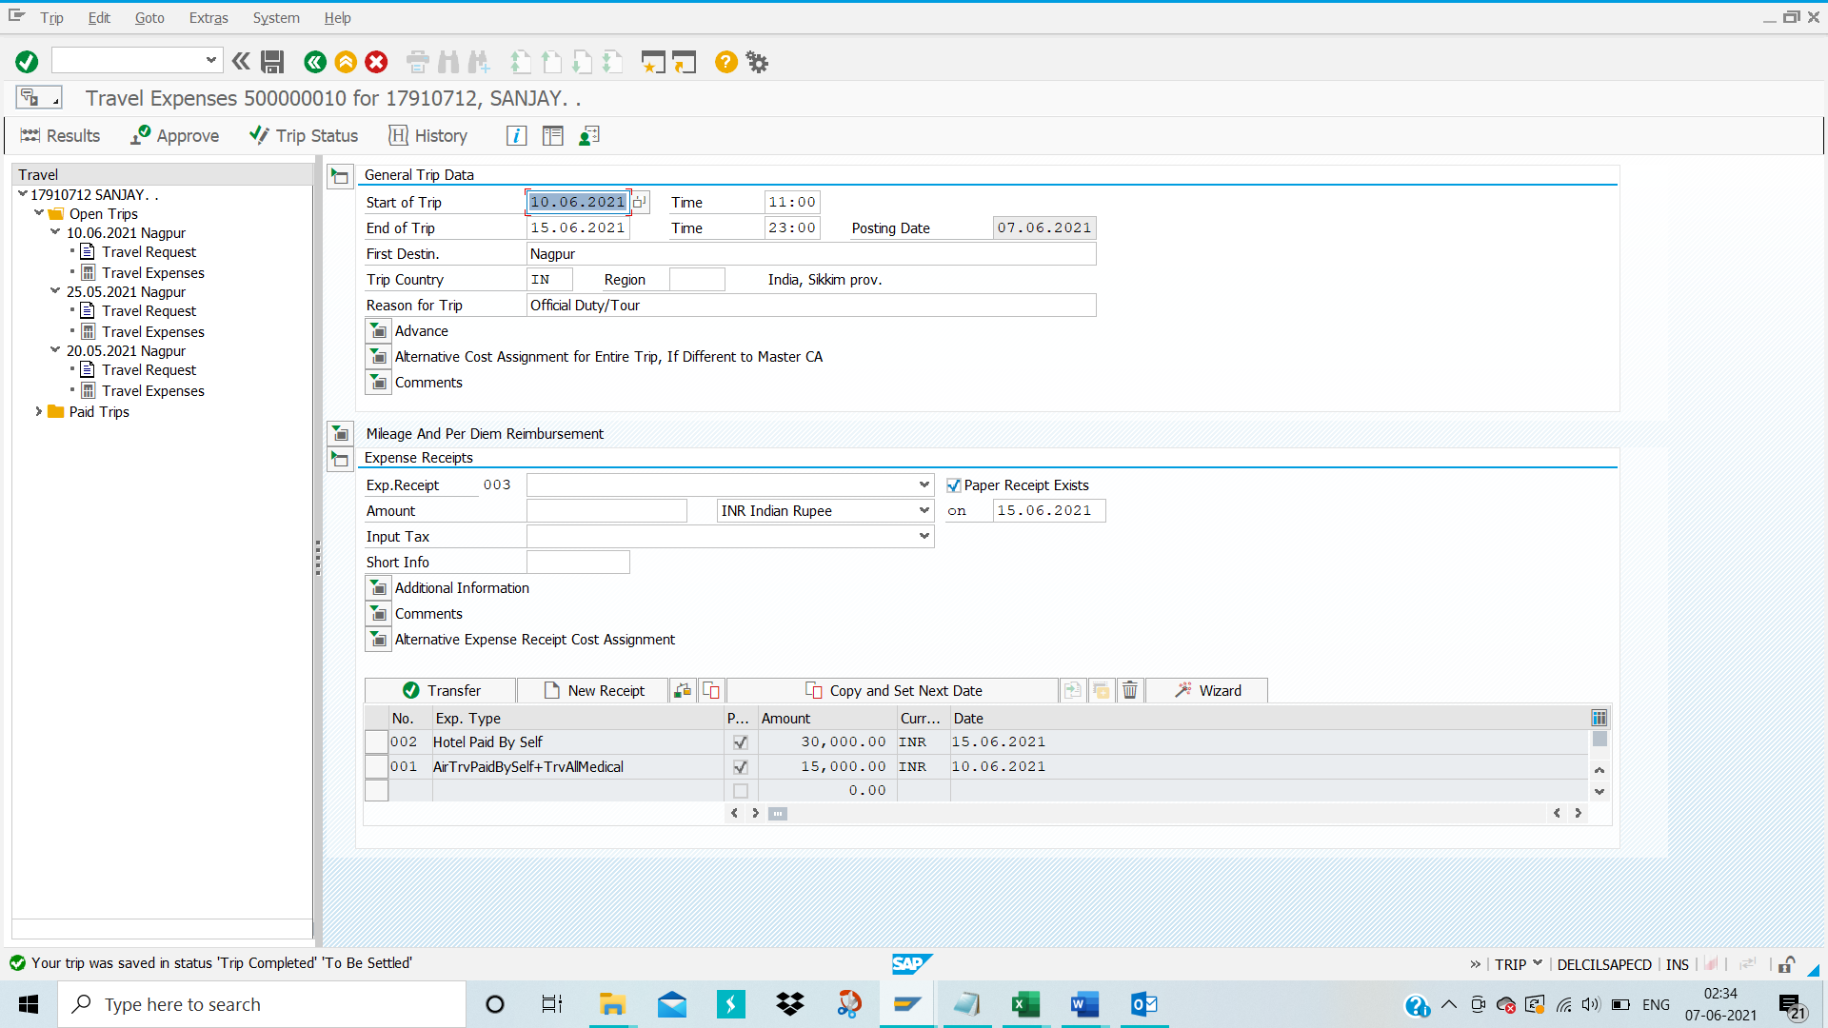
Then Trip will get saved and display message at bottom of the Screen Shot.

Completely come out of the TRIP screen.

Then again enter TRIP in command bar and then select employee’s personnel number
Place cursor on the travel expenses as shown below and click on ‘Display’ option

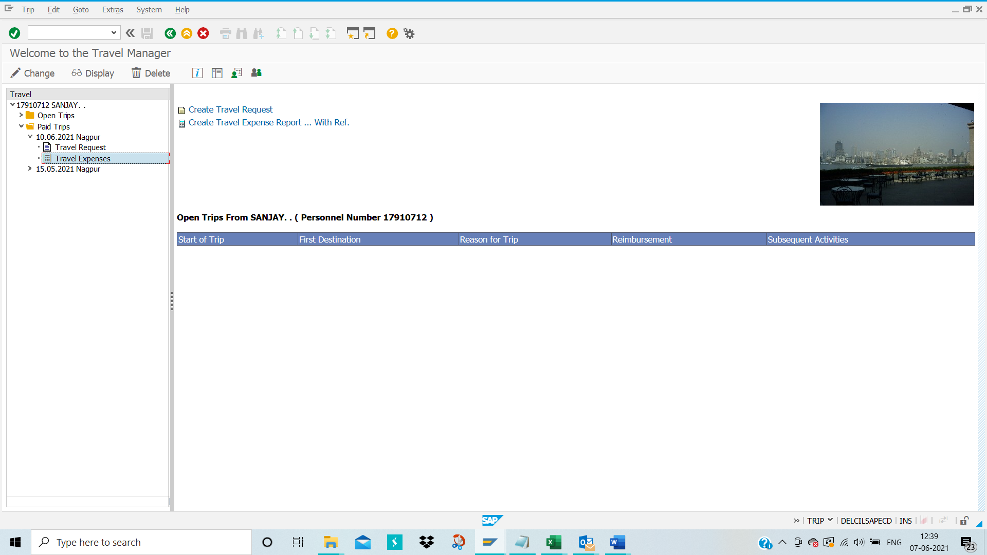
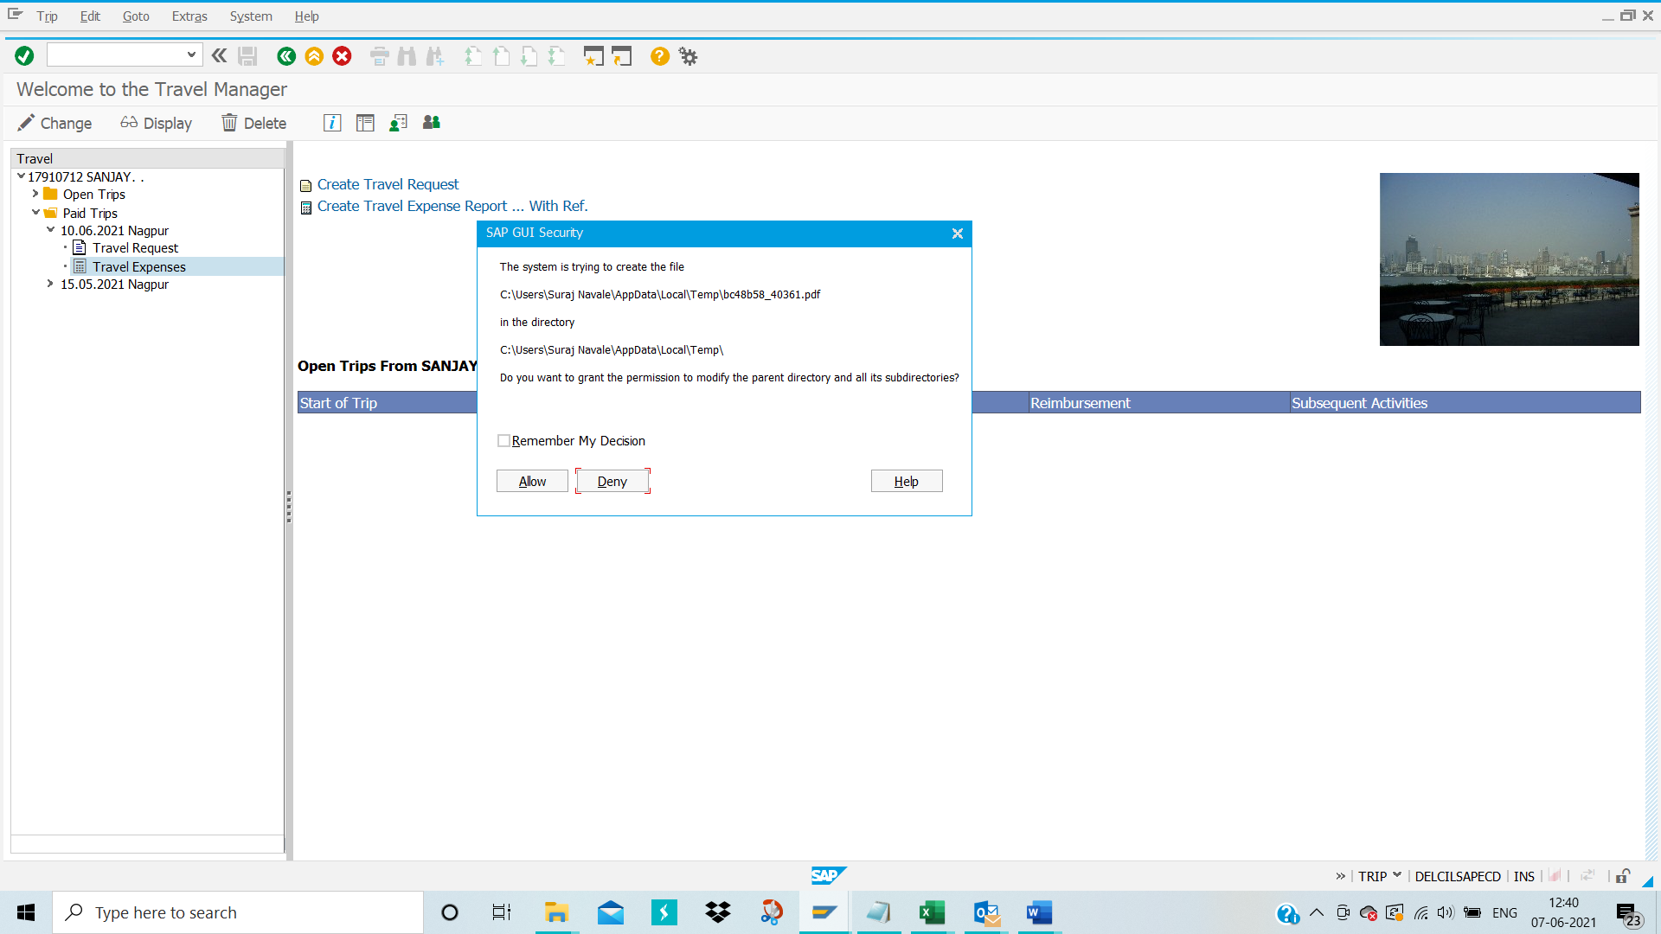
Click on ‘Allow’ option
Click on ‘Print’ option for printing the travel request for future reference
Click on ‘Save’ option for saving travel request form into your desktop

Approve Travel Expenses:
Again go to TCode- PR05 to approve Travel Expenses
Click Enter
Below Screen will appear:
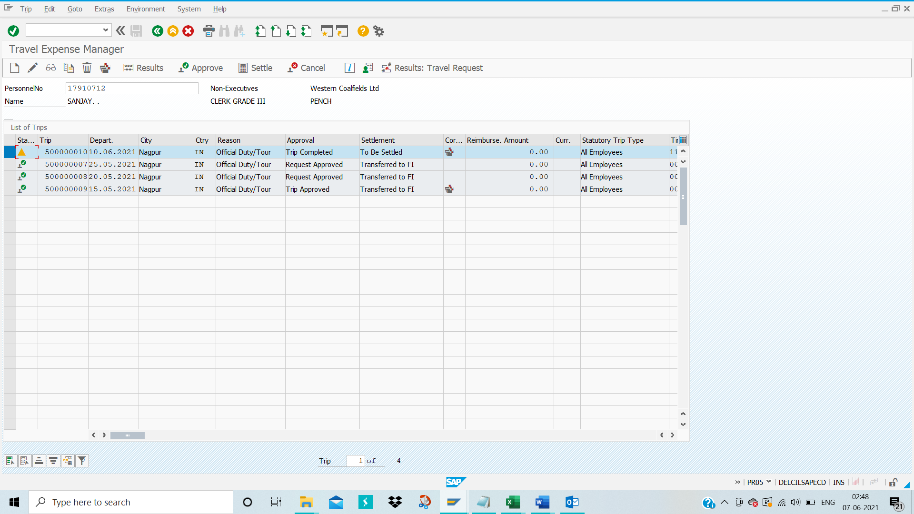
In Approval column it is showing Trip completed and to be settled
Then select the row and click on option
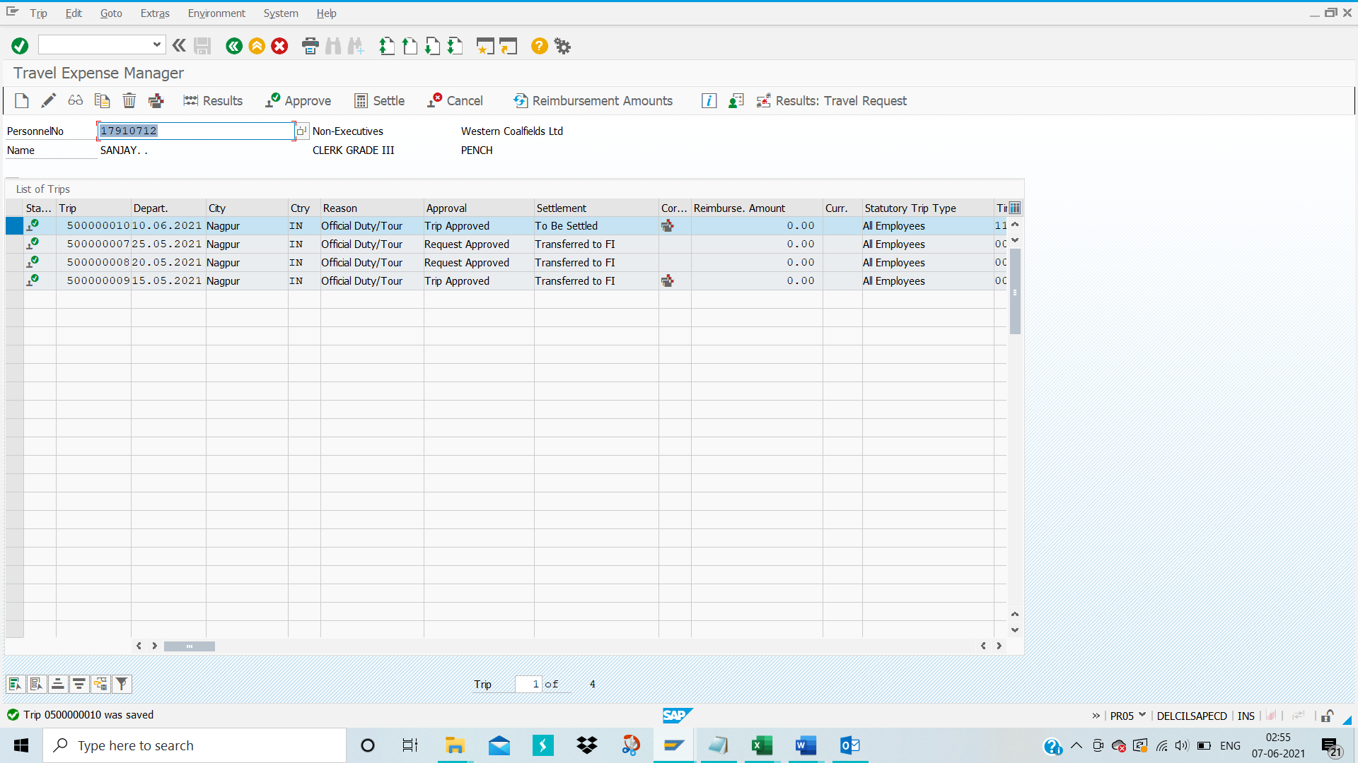
Status will change from to . In Approval column it will show “Trip Approved”.
Then again select row and click on .

Below pop up will show:
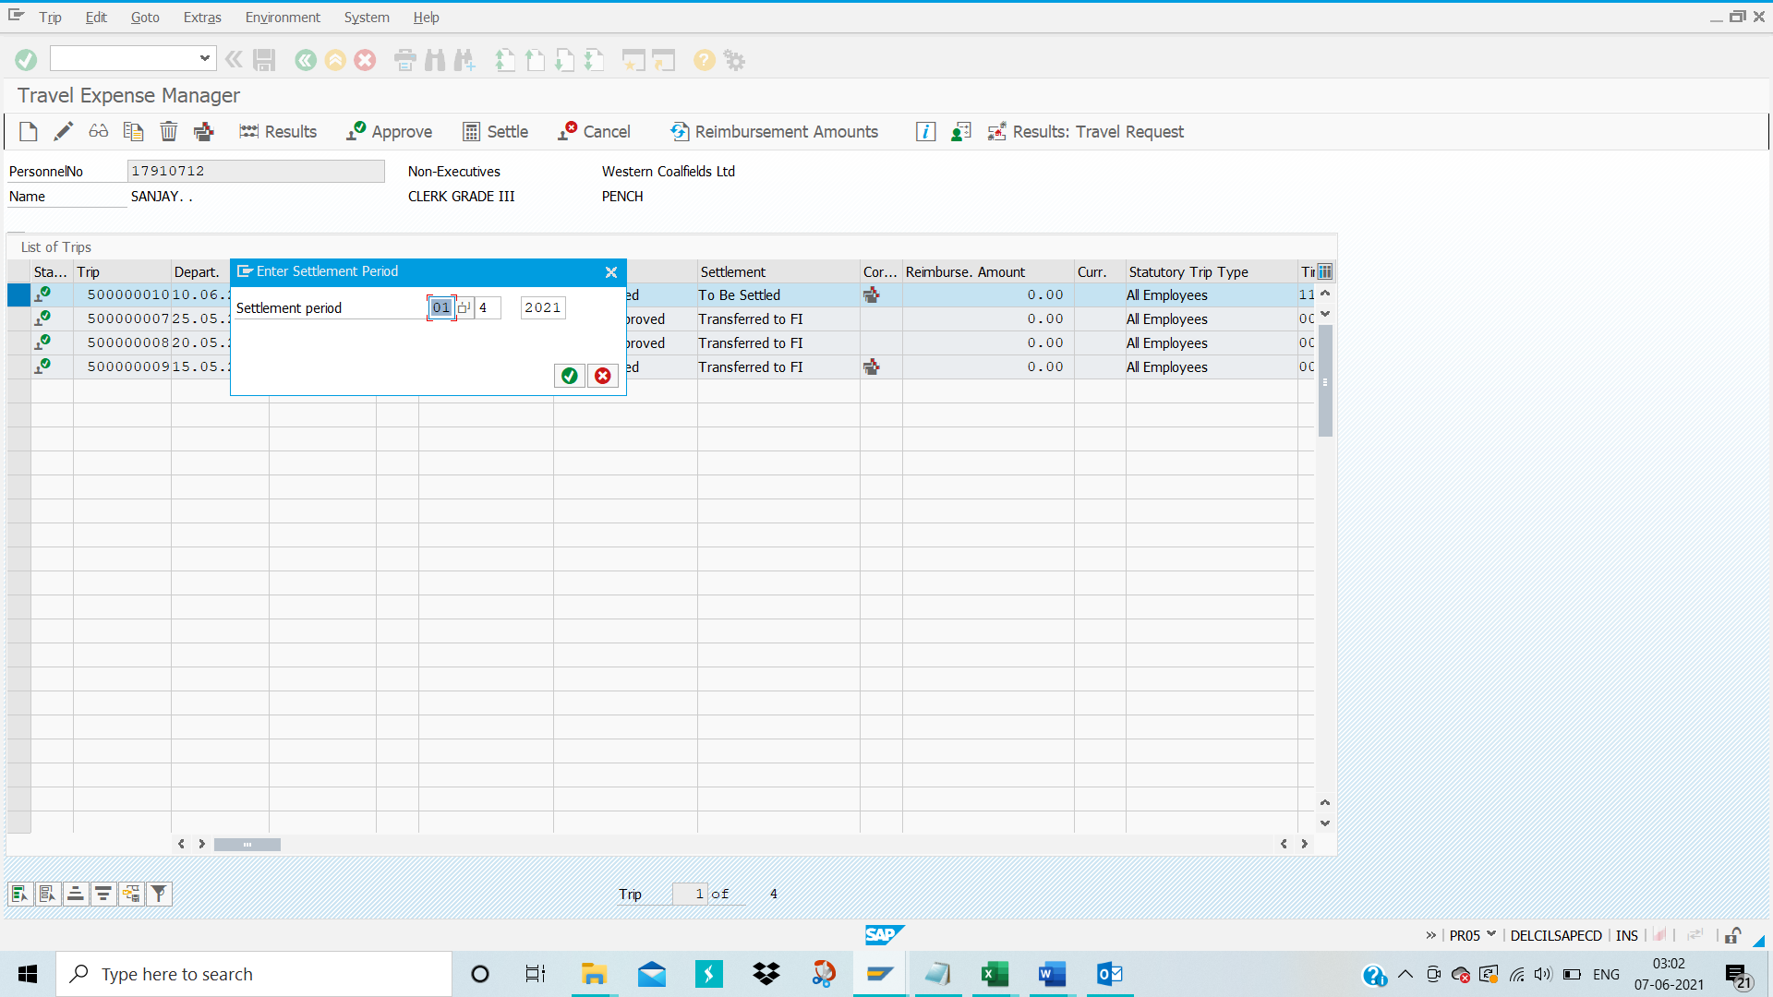
Click on Green button.
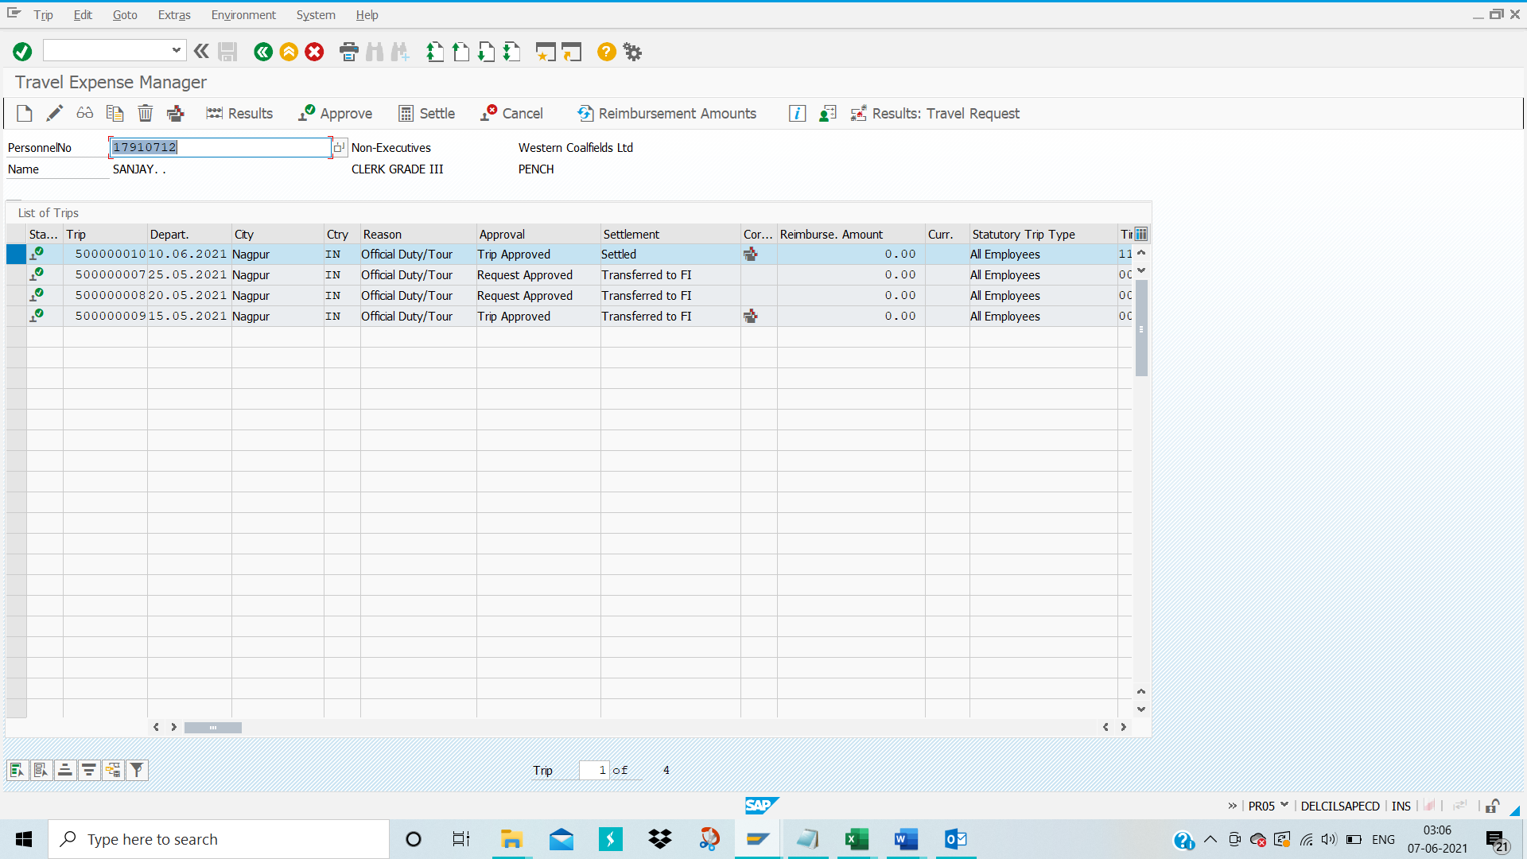
Settlement will change from to .
Completely come out of PR05 screen and go back to Tcode- PRFI to Create posting run for Travel expenses

Create Posting Run:
TCODE-PRFI
Enter TCODE-PRFI in the command bar and then press enter
Below screen will appear

Please fill the data for Payroll area, Personnel number and Trip Number
Please select ‘Trips’
Please deselect ‘Separation Allowances’
Please choose ‘Posting Run as simulation’
Please ‘choose incorrect CO objects’
Please click on ‘Execute’ icon
Below Screen will appear:
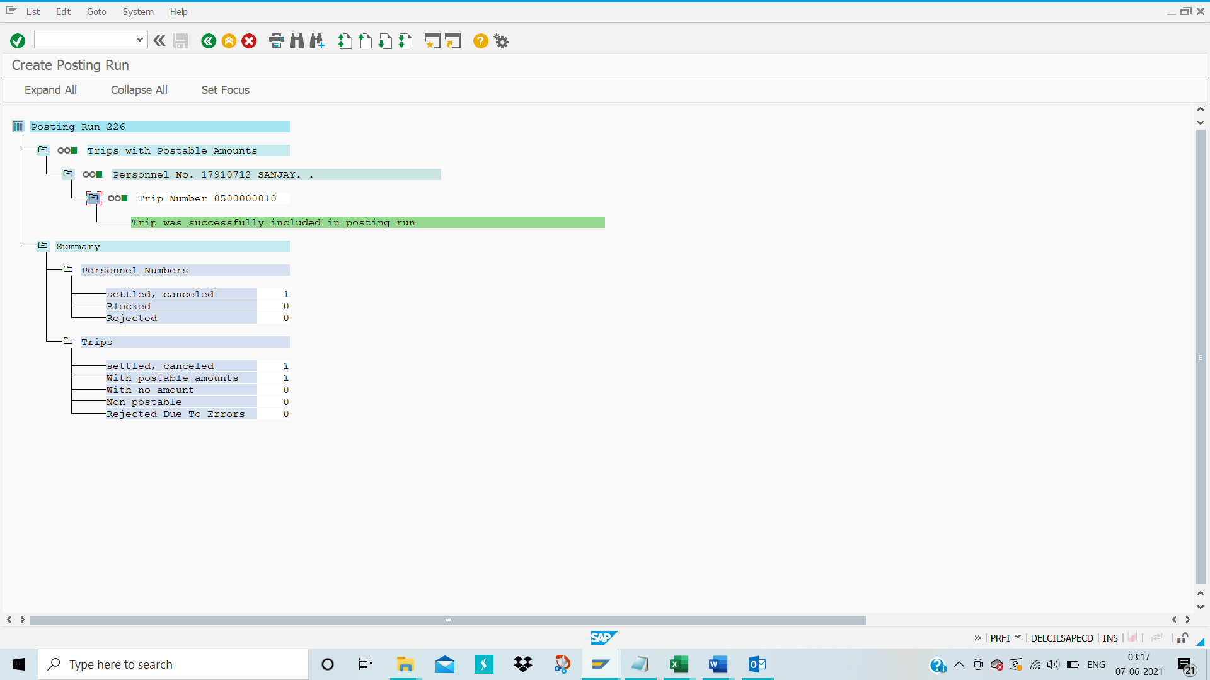
Now unselect ‘Posting Run as simulation’ and then execute

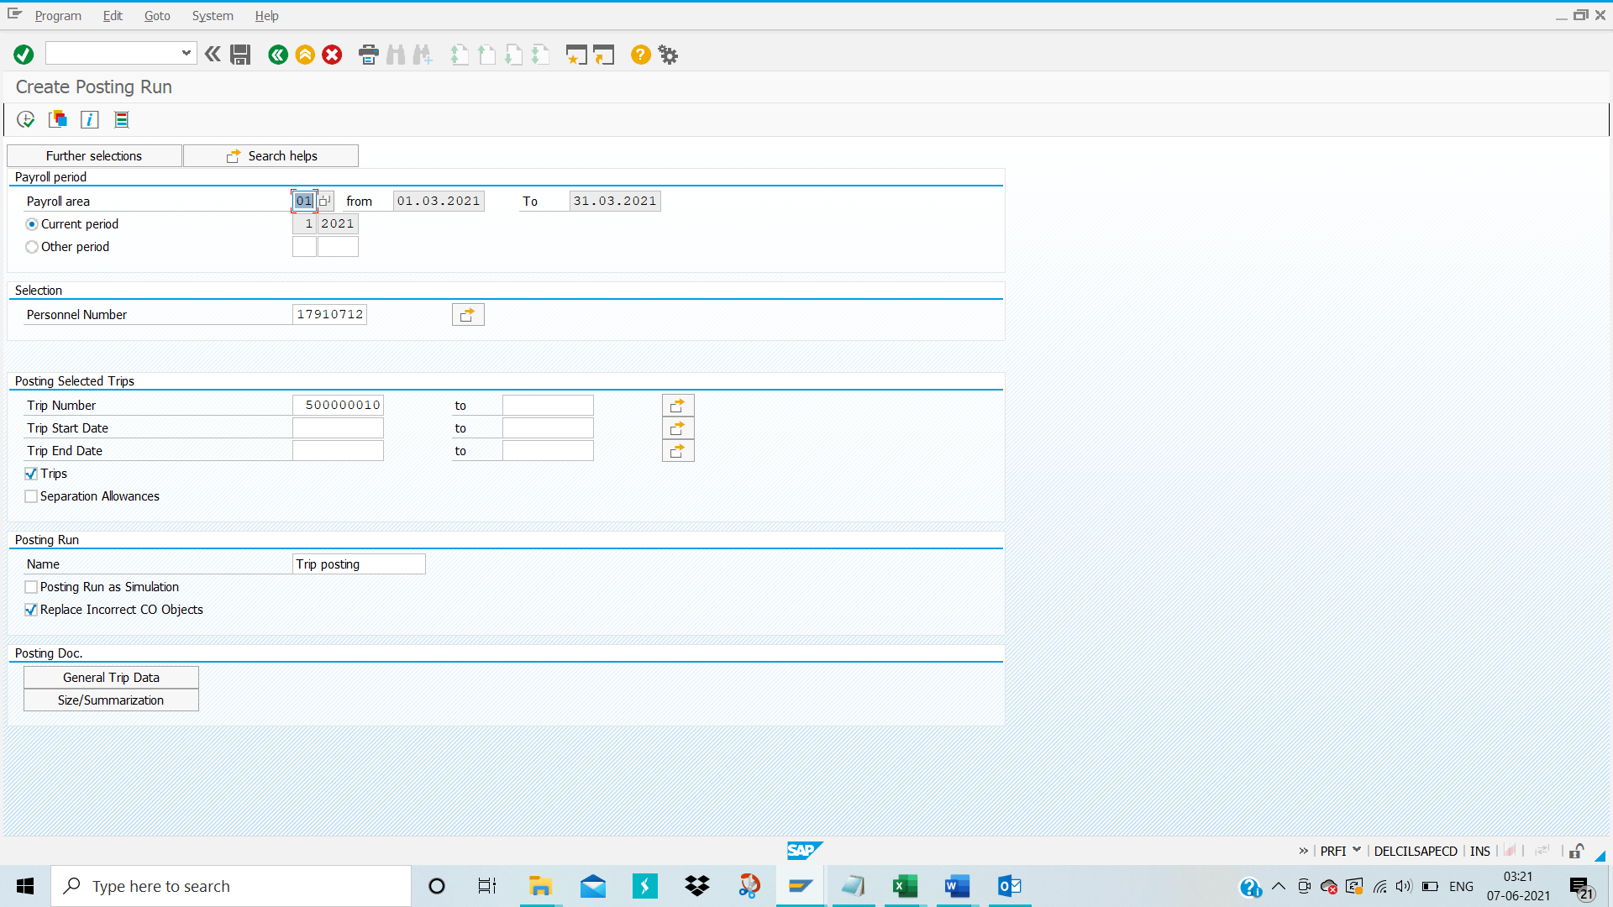
Below Screen appear:
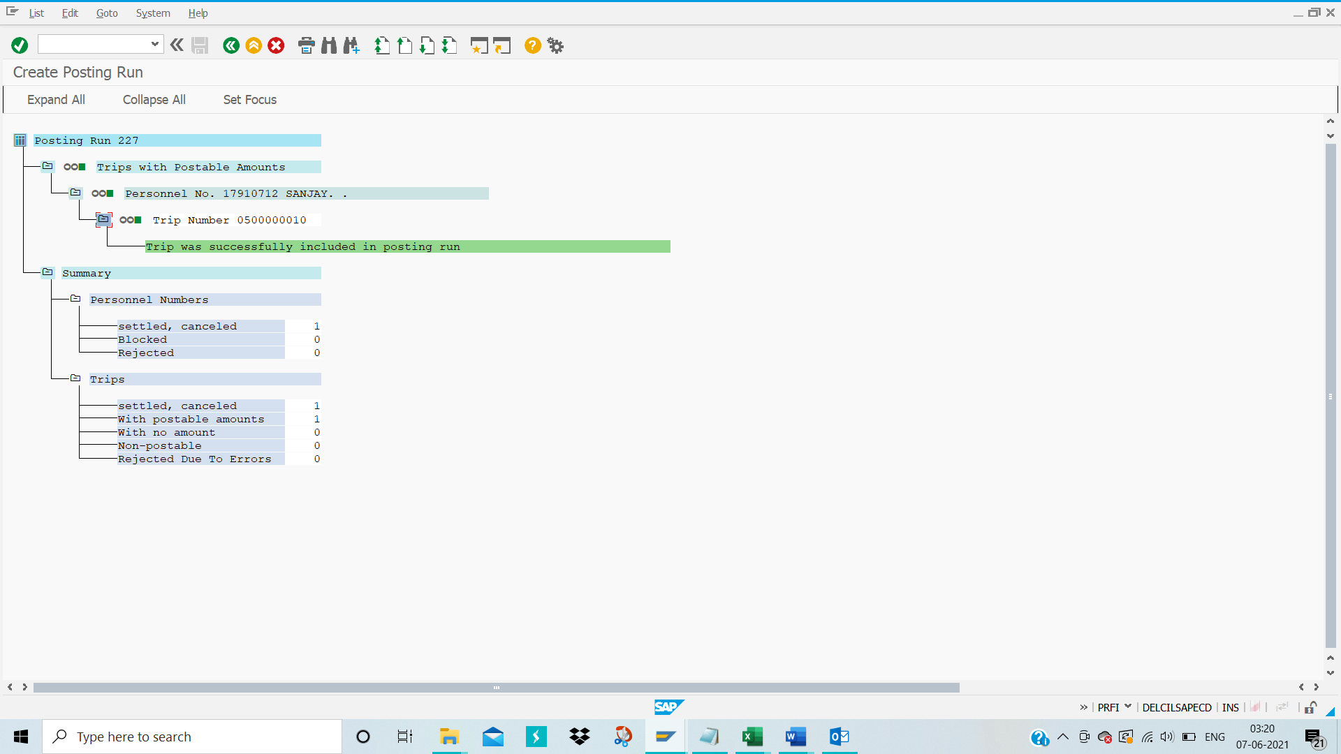
Completely come out of PRFI screen and go back to Tcode- PRRW to Posting run management for Travel expenses

Posting Run Management:
TCODE-PRRW
Enter TCODE-PRRW in the command bar and then press enter
Below screen will appear
Execute
In SI row it is blank it means Actual Posting
In SI row it is arrow it means simulation Posting

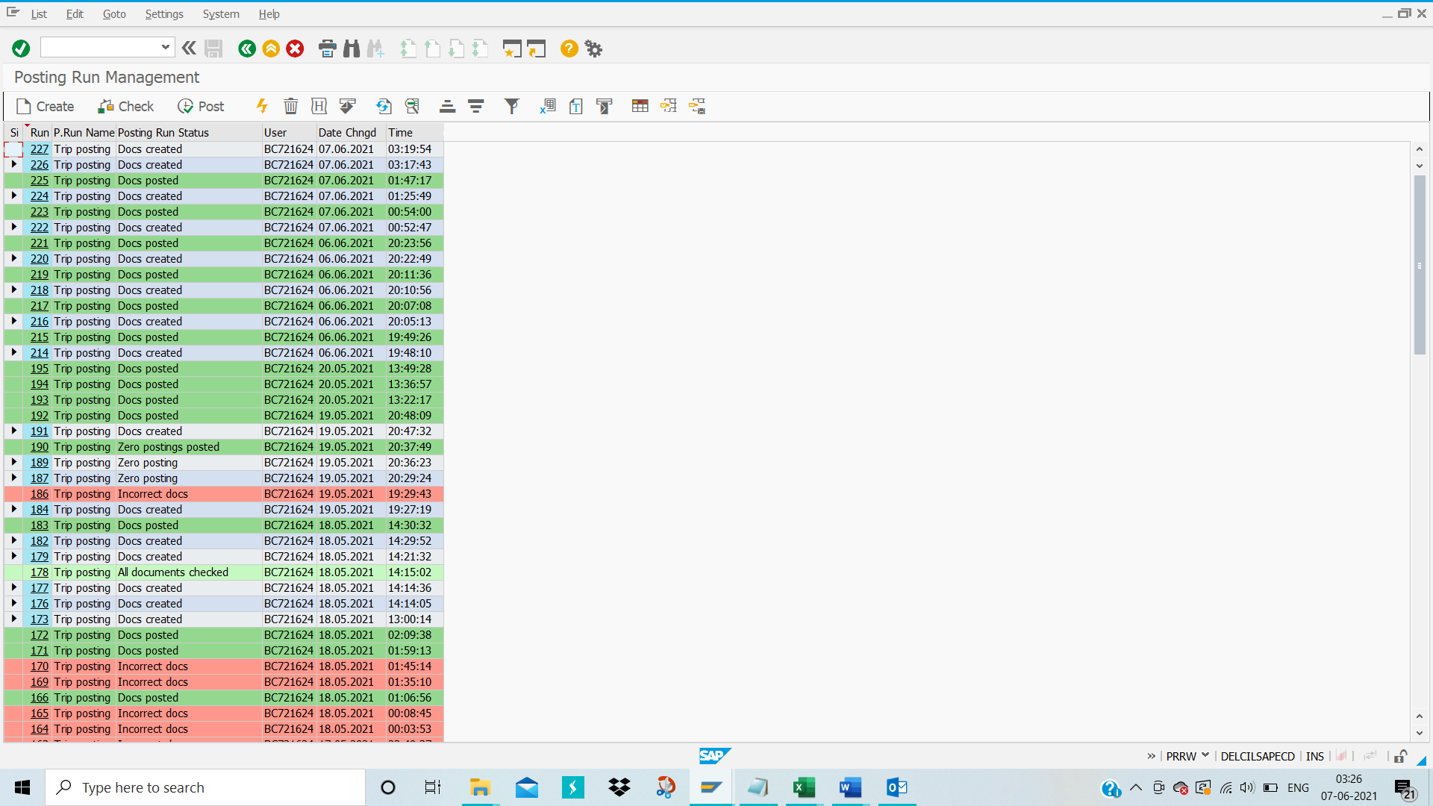
Select the Trip by clicking from SI row blank option then Click on ‘Check’ option to view the posting run document
The below screen appears
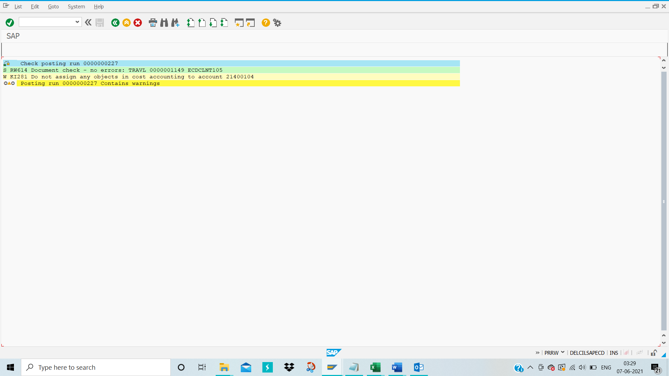
Click on the back green button.
Below Screen appears
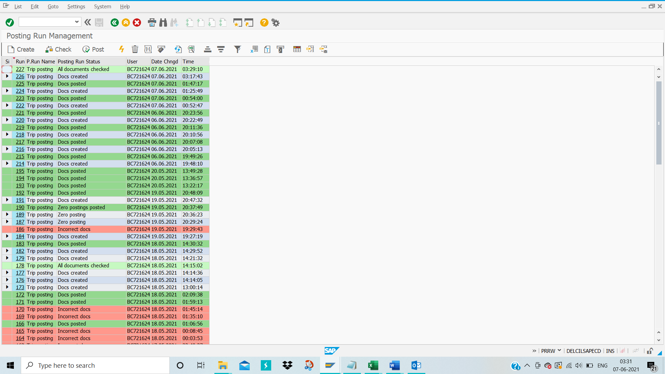
The posting run status changed from Docs created to All documents checked.
Select the row and click on “Post”
Below pop up will show “Run TR 0000000227 Post”
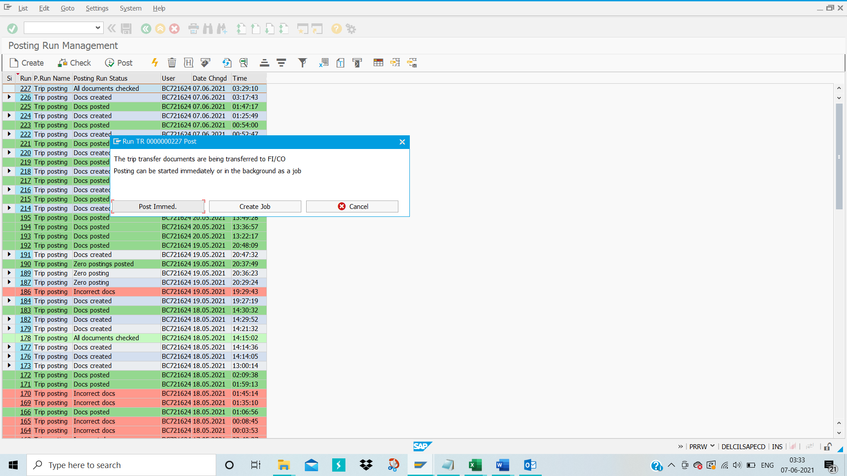
Click on the “Post Immed” button

Then below screen appears

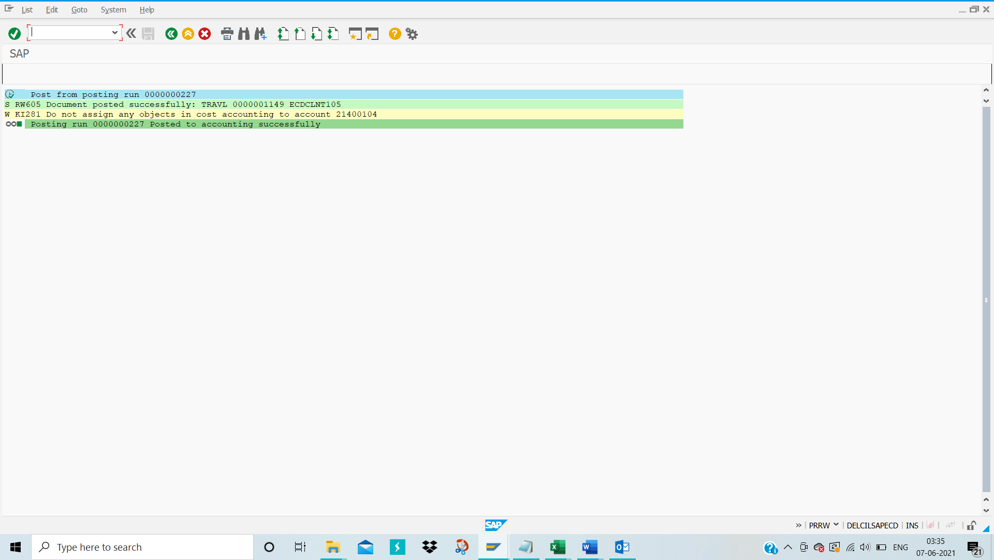
Now it is Successfully posted.
Follow the Same process for Executive

